**ONLINE QUIZ SYSTEM**

PROJECT SUBMITTED

FOR THE AWARD OF THE DEGREE OF

**BACHELOR OF COMPUTER APPLICATIONS**

IN

INFORMATION TECHNOLOGY / COMPUTER APPLICATION

FACULTY OF SCIENCE AND TECHNOLOGY

TO THE

AMITY UNIVERSITY, MAHARASHTRA, INDIA

Submitted by

**MR. AZIZ MALIK** **MR. AYUSH YADAV**

(Enrollment No: A71004821048) (Enrollment No: A71004821039)

Under the Guidance of

**DR. VIVEK MAHALE**

Assistant Professor, Amity Institute of Information Technology

**AMITY SCHOOL OF INFORMATION TECHNOLOGY**

**AMITY UNIVERSITY, MAHARASHTRA, INDIA**

**June 2024**

**TABLE OF CONTENTS**

|  |  |  |
| --- | --- | --- |
| **Sr. No.** | **Title** | **Page No.** |
| 1 | DECLARATION AND CERTIFICATE | 3 |
| 2 | ORIGINALITY REPORT | 4 |
| 3 | ACKNOWLEDGEMENT | 5 |
| 4 | LIST OF ACRONYMS AND ABBREVIATIONS | 6 |
| 5 | LIST OF TABLES | 7 |
| 6 | LIST OF FIGURES | 8 |
| 7 | ABSTRACT | 9 |
| 8 | INTRODUCTION | 10 |
| 9 | LITERATURE SURVEY | 27 |
| 10 | SYSTEM ANALYSIS | 38 |
| 11 | DESIGN | 46 |
| 12 | DATABASE | 60 |
| 13 | DIAGRAMS | 70 |
| 14 | IMPLEMENTATION | 74 |
| 15 | TABLES | 76 |
| 16 | TESTING | 81 |
| 17 | OUTPUT SCREENS | 88 |
| 18 | CONCLUSION AND FUTURE SCOPE | 98 |
| 19 | BIBLIOGRAPHY | 99 |



**DECLARATION AND CERTIFICATE**

This is to certify that this project report entitled: “ONLINE QUIZ SYSTEM” submitted by Mr. Aziz Malik and Mr. Ayush Yadav in partial fulfillment of the requirement of the degree of Bachelor of Computer Applications in the Amity Institute of Information Technology, Amity University Maharashtra, is based on the project and research work carried under the guidance and supervision of Dr. Vivek Mahale. The manuscript has been subjected to plagiarism check by TURNITIN software. This project report and any part thereof had not been submitted for any purpose to any University or Institute.

Place: Mumbai

Date: 29/4/24

Dr. Vivek Mahale Mr. Aziz Malik

Guide &

Amity University Maharashtra Mr. Ayush yadav

Student

Prof. (Dr.) Manoj Devare.

HOI, Amity Institute of Information Technology

Amity University Maharashtra.

**ORIGINALITY REPORT**

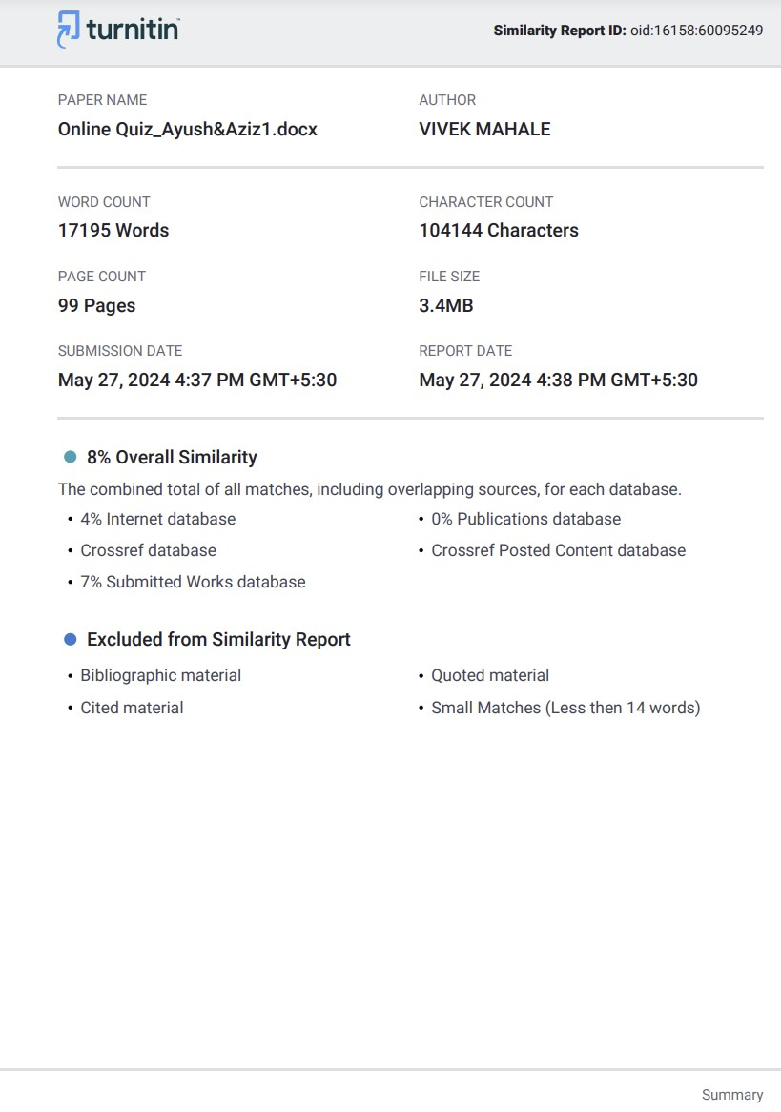

**ACKNOWLEDGMENTS**

First and foremost, I would like to acknowledge Amity University Mumbai for providing me with the necessary resources, facilities, and support throughout my academic journey.

I am grateful to my supervisor, Dr. Vivek Mahale, for his guidance, patience, and expertise. His constant encouragement, insightful feedback, and valuable suggestions have been instrumental in shaping the direction and quality of this report. I am truly fortunate to have had the opportunity to work under his supervision. I also owe a debt of gratitude to my friends and peers for their support, motivation, and stimulating discussions. Their willingness to lend a helping hand has been crucial to overcoming challenges and maintaining a positive research environment.

I could not possibly complete this section without crediting my family for their unconditional love, moral support, and understanding throughout my academic journey. Their thoughtfulness, encouragement, patience, and sacrifices have been the pillars of strength that have enabled me to pursue my aspirations and complete this report.

Lastly, I would like to express my heartfelt appreciation to all participants who took part in the research and shared their valuable insights. Their contributions have enriched this study and added depth to its findings. Thank you all for taking the time out to contribute your opinions and views on the subject matter and taking part in this remarkable journey.

_______________

AYUSH YADAV

_______________

AZIZ MALIK

**LIST OF ACRONYMS AND ABBREVIATIONS**

|  |  |
| --- | --- |
| **Abbreviation** | **Meaning** |
| HTML | Hypertext Markup Language |
| CSS | Cascading Style Sheets |
| JS | JavaScript |
| SQL | Structured Query Language |
| API | Application Programming Interface |
| URL | Uniform Resource Locator |
| HTTP | Hypertext Transfer Protocol |
| HTTPS | Hypertext Transfer Protocol Secure |
| XML | Extensible Markup Language |
| UI | User Interface |
| UX | User Experience |
| PaaS | Platform as a Service |

**LIST OF TABLES**

|  |  |  |
| --- | --- | --- |
| **Figure No.** | **Table Name** | **Page No.** |
| Fig 7 | Tables | 76 |
| Fig 8 | Admin | 76 |
| Fig 9 | Answer | 77 |
| Fig 10 | Feedback | 77 |
| Fig 11 | History | 78 |
| Fig 12 | Options | 78 |
| Fig 13 | Questions | 79 |
| Fig 14 | Rank | 79 |
| Fig 15 | Quiz | 80 |
| Fig 16 | User | 80 |

**LIST OF FIGURES**

|  |  |  |
| --- | --- | --- |
| **Figure No.** | **Figure Name** | **Page No.** |
|  |  |  |
|  | **DIAGRAMS** |  |
|  |  |  |
| Fig 1 | Architectural Overview of OES | 70 |
| Fig 2 | User | 70 |
| Fig 3 | Admin | 71 |
| Fig 4 | User/admin | 71 |
| Fig 5 | Class diagram for online quiz system | 72 |
| Fig 6 | Sequence diagram for online quiz system | 73 |
|  |  |  |
|  | **OUTPUT SCREENS** |  |
|  |  |  |
| Fig 17 | Login /Sign-in Page | 88 |
| Fig 18 | User Sign-In | 88 |
| Fig 19 | User Sign-Up | 89 |
| Fig 20 | Admin Login | 89 |
| Fig 21 | Developer Recognition | 90 |
| Fig 22 | Feedback Section | 90 |
| Fig 23 | Home | 92 |
| Fig 24 | User information | 92 |
| Fig 25 | Ranking | 93 |
| Fig 26 | Feedback | 93 |
| Fig 27 | Add/Remove Quiz | 94 |
| Fig 28 | Enter Quiz Details | 94 |
| Fig 29 | Remove quiz | 94 |
| Fig 30 | Sign-Out | 95 |
| Fig 31 | Dashboard/Home | 96 |
| Fig 32 | Exam history | 96 |
| Fig 33 | Ranking | 97 |

**ABSTRACT**

The project involves developing an Online Examination System aimed at simplifying the labor-intensive process of manually assessing candidates' answers. This system will significantly reduce the workload for teachers, administrators, and students by automatically and instantly checking responses, thereby alleviating student anxiety. By transitioning to an Online Examination System, the reliance on paperwork is minimized.

The system comprises modules such as the Admin/Examiner Module and the Student Module. As a web application, the Online Examination System (OES) allows for easy and accurate data retrieval from the database. It provides detailed results to students promptly. The OES facilitates the administration and taking of exams, as well as the maintenance of master information and the generation of various test reports.

The primary users of this project are students or members and system administrators. From an end-user perspective, the Examination System Project includes two main functional components: Enhanced Member Modules for registration, taking examinations, and managing profiles, and an Administration Module for managing members, examinations, question banks, and viewing reports.

# INTRODUCTION

Examinations are not only a test for the candidates but also pose a significant challenge for the management and teachers responsible for organizing them. Traditional examination methods involve extensive paperwork, manual checking of papers, compiling marks, and finally entering the results into a computer for report generation. The Online Examination System addresses most of the shortcomings associated with the traditional method.

With the Online Examination System, exams are conducted online, allowing users to take them from anywhere in the world. Results are automatically calculated immediately after the exam concludes, significantly reducing the potential for human error in result computation. Another key advantage of online exams is that data is stored in a structured format, enabling the generation of detailed reports, charts, and presentations over time. Additionally, accessing past exam papers, even those published a decade ago, becomes instantaneous.

**This document aims to analyze and elaborate on the high-level requirements of the Online Examination System.**

**The Technology of Online Quiz Systems**

The development of online quiz systems leverages web technologies such as HTML, CSS, JavaScript, and PHP to create dynamic, user-friendly platforms for creating and participating in quizzes. These systems provide interactive learning environments with instant feedback and multimedia elements to enhance the educational experience.

**Growing Apprehensions Regarding Online Quiz Systems**

Increased awareness of potential challenges associated with online quiz systems, such as ensuring data security, maintaining user engagement, and providing equal access to all users. Cases of technical issues or security breaches in online learning platforms have drawn attention to the need for robust, reliable systems.

**Inspiration to Take Action**

Understanding the significant benefits of well-designed online quiz systems, including improved learning outcomes, efficient assessment methods, and the ability to track and analyze performance data. Concerns about the potential negative impact of poorly implemented systems, such as reduced student engagement and compromised data security, drive the need for high-quality solutions.

**Establishment of Collaborative Efforts**

To tackle the challenges of developing an effective online quiz system, interdisciplinary teams of web developers, UI/UX designers, educational specialists, and cybersecurity experts must collaborate. By combining expertise from fields such as web development, educational psychology, and data security, comprehensive solutions can be created to enhance the learning experience and ensure system reliability and security.

**Team Contribution**

As part of the "Online Quiz System" Project, "Enhancing Learning Through Collaboration”.

My efforts, along with those of Ayush Yadav, made the "Online Quiz System" project a success. The foundation of our project was our collaboration, which enabled us to combine our abilities and successfully address the challenges associated with developing an interactive and user-friendly quiz platform.

**Allocation of Tasks and a Common Vision**

We collaborated closely throughout the entire project, motivated by a common goal of developing a seamless and engaging online quiz platform. Regular brainstorming sessions that promoted open communication allowed us to collectively develop project objectives, computational techniques, and user interface requirements. This cooperative approach ensured we stayed aligned throughout the development process.

**Equivalent Sets of Skills**

Our distinct skill sets were a fantastic match, even though our motivations for creating an efficient quiz system were the same. Ayush excelled at frontend development and user experience design, whereas my areas of competence were in backend development and database management. This division of labor allowed us to effectively tackle various areas of the project by utilizing our mutual expertise. However, our collaboration went beyond our assigned responsibilities as we constantly gave each other constructive criticism and encouragement during the project's development.

**Gaining Knowledge from Industry Best Practices: Utilizing Expert Perspectives**

During the project, we encountered several technical challenges and conceptual complexities related to web development and database management. We looked to industry-leading resources such as documentation, online tutorials, and expert forums for guidance on how to overcome these challenges. By examining the latest developments in web technologies and learning from seasoned experts, we enhanced our understanding and improved our approach to developing the "Online Quiz System."

**A Joint Victory**

The "Online Quiz System" project's success is evidence of our shared commitment to excellence and spirit of cooperation. By utilizing industry best practices, pooling our combined expertise, and maintaining open lines of communication, we successfully navigated the complexities of developing a robust quiz platform. Our culture of cooperation not only made the development process smoother but also instilled a sense of pride and ownership in the innovative solution we created together.

**Overview of the System**

Online examinations, also known as e-examinations, are conducted via the internet or an intranet (if within an organization) for remote candidates. Typically, these examinations provide immediate results once the candidate completes the exam, thanks to an integrated answer processing module.

E-examinations efficiently evaluate candidates through a fully automated system, saving significant time and delivering rapid results. They allow students to take exams at their convenience without the need for traditional materials like paper and pen. These exams are often open-book, giving candidates a limited time to answer the questions. Once the time expires, the answer sheet is automatically disabled, and the responses are sent to the examiner for evaluation. The evaluation can be automated or manual, with results communicated via email or made available on the website. Many organizations worldwide successfully conduct online examinations and issue results online.

Online examinations offer several advantages and some disadvantages. The main advantage is their ability to accommodate remote candidates, with the evaluation of answers, particularly multiple-choice questions, being fully automated or manually processed depending on the question type and requirements. Online exams can be conducted anytime and are more cost-effective than traditional exams since they eliminate the need for physical materials like printed exam papers and admission forms. After establishing the online exam system, the costs are minimal, excluding maintenance.

Various methodologies are employed in these examinations for candidate registration and question presentation to effectively test the candidates' knowledge and skills. Despite the open-book format, the limited time ensures that candidates cannot rely solely on reference materials or external assistance.

**Influences and Inspirations: Crafting a Fusion of Web Development and Educational Expertise**

The "Online Quiz System" was developed using a combination of web development knowledge and industry best practices for educational technology. Here, we explore the particular influences that have shaped our project's fundamental algorithms, data processing techniques, and overall ethos.

**Best Practices for Online Quiz Systems**

**Leveraging Cutting-Edge Techniques**

Many academic articles, market reports, and professional forums devoted to educational technology inspire our approach. We aim to apply state-of-the-art algorithms and techniques that enhance user interaction and experience. By staying up-to-date with the latest advancements, we ensure our system is both innovative and effective. This includes studying various web frameworks and exploring methods for real-time data processing and user engagement.

**Acquiring Knowledge from Established Frameworks**

Important frameworks like Moodle, Blackboard, and Quizlet provide guidelines for the architecture and workflow of our project. By examining these frameworks, we learn valuable techniques for user interface design, data management, and system integration. For instance, we have adopted methods for intuitive navigation and responsive design, ensuring our platform is accessible on various devices. We have also implemented robust data handling practices to ensure the reliability and security of user data.

**Proficiency in Web Development and Educational Strategies**

**Knowledge of User Engagement Techniques**

Our project benefits from insights into user engagement strategies used in the edtech space. By incorporating elements such as gamification, instant feedback, and multimedia content, we enhance the learning experience and maintain user interest. We regularly review successful educational platforms to refine our approach and implement features that have proven effective in similar contexts.

**Using the Principles of Educational Technology**

Our approach to developing a user-friendly and effective quiz system is based on educational technology principles such as personalized learning, formative assessment, and interactive content. For example, we use adaptive algorithms to tailor quizzes to individual user levels and preferences. Additionally, we employ analytics tools to track and assess user performance, providing insights for continuous improvement.

**A Fusion That Is Not Only Influential**

The "Online Quiz System" cleverly combines web development methodologies with educational principles, going beyond simple replication of existing solutions. By integrating cutting-edge web technologies, data integrity verification methods, and real-time user feedback mechanisms, we aim to create a comprehensive solution that addresses the evolving needs of digital education.

**Cutting-Edge Web Development Techniques**

Hybrid Models for Feature Integration:

We use hybrid models that combine the best aspects of various web technologies. For example, we use Bootstrap for responsive design and jQuery for enhanced interactivity. This fusion allows us to capture both the functional and aesthetic aspects, improving the overall user experience.

**Methods for Ensuring Data Integrity**

We employ data validation techniques to ensure the accuracy and integrity of our data. This includes input validation, data sanitization, and secure database management practices. These measures help maintain high data quality and prevent issues such as data breaches or corruption.

**Real-Time Monitoring Capabilities**

Our system's real-time functionality allows users to receive instant feedback on quiz submissions and overall performance. This is achieved through the use of AJAX for asynchronous data loading and WebSockets for real-time updates, minimizing latency and enhancing user experience.

**Collaborative Development and Community Engagement**

**Encouraging User Contributions**

We invited community members to demonstrate their creativity and technical expertise in developing quiz content and features through interactive challenges and collaborative projects. This collaborative attitude added fresh ideas and perspectives to the project, fostering a sense of community and shared ownership.

**User-Generated Content**

We provided community members with opportunities to contribute their own quiz questions, algorithms, and design suggestions. By integrating user-generated content into the "Online Quiz System," we aim to create a dynamic ecosystem that continually evolves and adapts to new educational needs and challenges.

**Sessions for Community Feedback**

We regularly utilized focus groups, online forums, and surveys to gather feedback from users. This ongoing communication allowed us to prioritize feature updates, identify areas for improvement, and address user concerns, ensuring that the "Online Quiz System" evolves to meet the needs of its user base.

**Creating a Common Vision**

Through continuous interaction with the educational technology community, the "Online Quiz System" has developed into a project that truly embodies the expertise, enthusiasm, and commitment of all its participants. By adopting a community-driven development model, we aim to create a system that not only meets user needs but also fosters a sense of community and shared ownership in the advancement of digital education. Together, we are building a future where learning is engaging, interactive, and accessible to all.

**Aim of the Project**

The primary aim of this project is to develop an advanced online examination system by applying established software engineering principles and best practices. This system will be constructed using widely-adopted Java/J2EE web technologies and frameworks to ensure it is scalable, secure, and robust, meeting the needs of a diverse user base.

The online examination system will streamline the examination process significantly. It will enable teachers to create exams efficiently by compiling a set of questions, which can be either multiple-choice or text-based. This system will utilize a question database to automatically process exam results. One of its intelligent features includes the ability to mark text-based answers by recognizing not only exact matches but also similar answers through the identification of synonyms, thereby providing a more nuanced evaluation of student responses.

Moreover, the system will incorporate a manual override feature, granting teachers the flexibility to manually grade or update exam results when necessary. This ensures that all types of questions and answers can be accurately assessed, maintaining the integrity of the examination process.

Another key feature of the system is its ability to allow students to resume their exams from the last save point. This means that if a student needs to pause their examination, they can restart it at any other time without losing their progress. This functionality is particularly beneficial in accommodating unforeseen interruptions, making the examination process more flexible and accessible.

The user interface of the system is designed to be intuitive and user-friendly, catering to teachers, students, and administrators alike. Once logged in, students will have access to a dashboard where they can view their scheduled exams and take them at their convenience. Teachers, on the other hand, will have tools to create, manage, and grade exams, while administrators will be able to oversee the entire process, ensuring smooth operation and data integrity.

In summary, the aim of this project is to develop a comprehensive online examination system that not only facilitates the creation and grading of exams but also enhances the overall experience for all users involved. By leveraging modern web technologies and adhering to best practices in software engineering, the system will offer a reliable, efficient, and user-friendly solution to the challenges posed by traditional examination methods.

**Shaping the Future of Online Quiz Systems**

Promoting ethical practices and prioritizing user-centric concerns are essential as online quiz systems continue to evolve. Addressing issues like user data privacy, fairness in quiz content, and transparency in system operations are all part of this.

**Data Privacy**

User data privacy is crucial, especially in applications that collect personal information. We employ meticulous techniques to ensure data privacy throughout the entire system development process. This includes using secure data storage methods, ensuring data encryption, and adhering to privacy regulations such as GDPR.

**Fairness in Quiz Content**

Fairness ensures that no specific group is disproportionately affected by our quiz content. We incorporate diverse and representative questions to cater to various knowledge levels and backgrounds. This entails regular content audits and assessing our quizzes for any biases or unfair representations.

**Transparency in System Operations**

Transparency is essential to develop user trust in online quiz systems. We offer clear explanations of our data usage policies, provide detailed documentation of our quiz generation process, and ensure that users understand how their data is managed. Through transparency about our processes, we encourage responsibility and confidence in our online quiz system.

**Ethical Frameworks and Guidelines**

We adhere to recognized ethical frameworks and standards, such as the GDPR for data protection and industry best practices for educational technology. These guidelines ensure that our work aligns with ethical standards and societal values.

**Inter-Domain Cooperation**

Shaping the future of online quiz systems requires cooperation across multiple domains. By leveraging diverse expertise and resources through collaborations and knowledge sharing, we develop comprehensive and robust solutions.

**Academic Collaboration**

Working with academic institutions enables us to stay updated with the latest research and theoretical advancements. Important components of our collaborative activities include conferences, research partnerships, and scholarly publications.

**Industry Partnerships**

Collaborating with industry leaders helps us translate research into practical applications. These partnerships provide us with advanced computing resources, extensive datasets, and real-world testing conditions.

**Government and Policy Engagement**

Interacting with policymakers and government agencies ensures that our work aligns with legal requirements and societal needs. We participate in policy discussions, offer expert testimony, and help shape standards and regulations for online quiz systems.

**Civil Society Involvement**

Engaging with civil society organizations ensures that our solutions address the needs of diverse stakeholders and helps us understand the societal impacts of our technology. These partnerships also support outreach and educational programs.

**Constant Innovation and Adaptation**

The landscape of educational technology is dynamic, requiring ongoing innovation and adaptation in online quiz systems.

**Keeping Up with New Developments**

We monitor the latest developments in educational technology and artificial intelligence to ensure our system remains effective and up-to-date. This involves engaging with the broader tech community, participating in research consortia, and attending industry conferences.

**Adapting to User Needs**

Predicting and understanding user needs is essential to maintaining the relevance and effectiveness of our system. We regularly conduct user testing and gather feedback to refine and enhance our platform.

**Advancements in Web Development**

We invest in research and development to incorporate the latest advancements in web development and user experience. This includes exploring new frameworks, optimization techniques, and hybrid models that combine various web technologies for improved performance.

**Knowledge and Awareness**

Educating users and stakeholders about the benefits and functionalities of online quiz systems is essential for shaping the future of digital education.

**Educational Initiatives**

We host workshops, webinars, and training sessions to increase public awareness of our online quiz system and its benefits. These activities target various audiences, including educators, students, and technical professionals.

**User Guides and Documentation**

We provide comprehensive user guides and documentation to help users understand how to effectively use our online quiz system. This includes step-by-step tutorials, FAQs, and support resources.

**Community Engagement**

We actively engage with our user community through forums, feedback sessions, and surveys. This ongoing communication ensures that our system evolves to meet the needs of its users and fosters a sense of community and shared ownership.

**Existing System**

Traditionally, the process of assigning tests and evaluating scores has been manual. This involves several steps: preparing test papers, administering exams, checking answers, and distributing scores, all of which are time-consuming tasks. The existing system relies heavily on human intervention, making it labor-intensive and prone to various inefficiencies.

**Disadvantages of the Current System**

1. Time-Consuming Process: The manual system requires significant time to prepare, conduct, and evaluate examinations. Each step, from setting the questions to grading the papers, is labor-intensive
2. Need for More Invigilators: Conducting exams for a large number of candidates necessitates a proportional increase in the number of invigilators to ensure proper supervision. In contrast, online examinations can be administered without the need for physical invigilators.
3. Higher Risk of Paper Leakage: The manual handling of exam papers increases the risk of paper leakage. Exam papers need to be printed, stored securely, and distributed appropriately, all of which pose opportunities for security breaches.
4. Slow Result Processing: Since the evaluation of test papers and the calculation of scores are done manually, the process is inherently slow. This delay can affect the timely announcement of results and subsequent academic decisions.
5. Challenges in Analyzing Exam Results: Analyzing results manually to derive meaningful insights or statistics is cumbersome. It requires additional time and effort to compile and interpret the data.
6. Prone to Errors: Manual evaluation is susceptible to errors. Mistakes in marking answers or calculating scores can lead to inaccuracies in the final results, potentially affecting the fairness and reliability of the examination process.

Overall, the traditional manual system for conducting examinations is fraught with inefficiencies and vulnerabilities that can be effectively addressed through a modern, automated online examination system.

Proposed System

The proposed computerized system aims to address the numerous drawbacks of the existing manual examination system. By leveraging modern technology, this system offers a wide range of advantages designed to enhance efficiency, accuracy, and user experience. The proposed online examination system will be highly personalized and user-friendly, ensuring that even new users can easily navigate and utilize all available options. Data entry will be quick and straightforward, further streamlining the examination process.

**Advantages of the Proposed System**

1. Personalized and Intuitive Interface: The system will feature a personalized interface that is easy to understand and navigate. This design ensures that users, whether they are students, teachers, or administrators, can quickly become proficient in using the system without extensive training.
2. Efficient Data Entry: The system will facilitate quick and efficient data entry, reducing the time and effort required to input information. This includes the creation of exams, entry of student information, and recording of results.
3. User-Friendly Design: The system's design will simplify navigation, making it accessible and easy to use for all users. Clear instructions and intuitive controls will help users perform their tasks efficiently.
4. Reduced Need for Invigilators: Unlike traditional exams that require a large number of invigilators to monitor students, the online system will minimize or eliminate the need for physical supervision. Automated monitoring tools can ensure the integrity of the examination process.
5. Minimized Risk of Paper Leakage: By conducting exams online, the system significantly reduces the risk of paper leakage. Exam questions and answers are securely stored and transmitted electronically, eliminating the vulnerabilities associated with physical exam papers.
6. Faster Result Processing: The system will automate the evaluation of exam results, allowing for instant grading and feedback. This immediate processing not only saves time but also enables students to receive their results as soon as they complete the exam.
7. Improved Accuracy and Reduced Errors: Automated evaluation reduces the likelihood of human errors in marking and calculating scores. This ensures that results are precise and reliable, maintaining the fairness and integrity of the examination process.
8. Enhanced Data Analysis: The system will offer advanced capabilities for analyzing exam data. Detailed reports, charts, and statistical analyses can be generated to provide insights into student performance and exam effectiveness.
9. Time and Cost Efficiency: Compared to the current system, the proposed system will be significantly less time-consuming and more efficient. The automation of various processes will reduce operational costs and save valuable time for educators and administrators.
10. Instant Result Generation: Students will receive their exam results immediately upon completion, eliminating the waiting period associated with manual grading. This prompt feedback can enhance the learning experience and inform subsequent academic decisions.
11. Comprehensive Record Keeping: The system will maintain detailed logs of student participation and performance. These records will be stored in a database for future reference, enabling easy retrieval and review of historical data.
12. Precision and Reliability: The automated nature of the system ensures that results are both precise and accurate. This reliability is crucial for maintaining the credibility of the examination process and for making informed decisions based on the results.

In conclusion, the proposed online examination system will revolutionize the traditional examination process by making it faster, more accurate, and more user-friendly. By addressing the inefficiencies and vulnerabilities of the current system, this modern solution will provide a seamless and reliable platform for conducting exams, benefiting students, teachers, and administrators alike.

**Feasibility Study**

**Technical Feasibility**

Evaluating technical feasibility is a critical and complex component of a feasibility study. This stage is challenging because, at this point, comprehensive details about the system may not be available. This lack of information makes it difficult to accurately assess potential issues such as performance capabilities and cost implications related to the chosen technology. A thorough technical analysis must consider several factors, including:

- Technology Requirements: Understanding the hardware and software requirements for the new system and determining whether the current infrastructure can support these needs.

- Compatibility: Ensuring that the new system will be compatible with existing systems and technologies used within the organization.

- Scalability: Evaluating whether the system can be scaled to meet future demands without significant modifications.

- Expertise and Training: Assessing the availability of technical expertise within the organization and the need for additional training for staff to manage and maintain the new system.

- Security: Identifying potential security risks and determining whether the proposed technology can provide adequate protection against these threats.

- Maintenance and Support: Considering the long-term maintenance and support requirements of the new system and whether the organization can meet these needs.

**Operational Feasibility**

Operational feasibility assesses whether the proposed project can be turned into a working information system that meets the operational requirements of the organization. This part of the feasibility study asks whether the system will function effectively when it is developed and installed and whether there are significant barriers to implementation. Key considerations include:

- Support from Management and Users: It is crucial to have strong support from both management and end-users. Without their backing, even the most technically sound systems can fail. If the current system is highly regarded and widely used, there may be resistance to adopting a new system.

- User Satisfaction with Current Methods: If users are dissatisfied with the current business methods, they may be more receptive to a new system that promises improved operations and functionality. Understanding user pain points can help in designing a system that addresses these issues.

- User Involvement in Planning and Development: Involving users early in the planning and development stages can significantly reduce resistance to the new system. When users feel that their input is valued and that they have a stake in the project's success, they are more likely to support and adopt the new system.

- Operational Requirements: Identifying and understanding the operational requirements that the new system must meet is essential. This includes workflow integration, process automation, and any specific functionality that is critical for the organization's operations.

- Implementation Barriers: Assessing potential barriers to implementation, such as resistance to change, technical challenges, and resource limitations, is crucial. Developing strategies to mitigate these barriers can help ensure a smooth transition to the new system.

**Economic Feasibility**

Economic feasibility evaluates the financial aspects of the project by comparing the costs of developing and implementing the new system with the benefits it is expected to provide. This analysis provides top management with the economic justification for the new system. Key components of economic feasibility include:

- Cost-Benefit Analysis: Performing a detailed cost-benefit analysis to compare the anticipated costs of the new system with the expected benefits. Costs may include development, implementation, training, maintenance, and support, while benefits might include increased efficiency, reduced operational costs, and improved accuracy.

- Return on Investment (ROI): Calculating the expected return on investment to determine whether the financial benefits of the new system outweigh the costs. A positive ROI indicates that the project is economically viable.

- Budget Considerations: Ensuring that the project can be completed within the allocated budget. This involves detailed financial planning and monitoring to avoid cost overruns.

- Cost Comparison with Current System: Comparing the costs of the new system with those of maintaining and operating the existing system. This comparison helps to highlight the potential cost savings and efficiency gains from the new system.

- Economic Justification: Providing a clear economic justification for the new system to top management. This involves presenting a compelling case for how the new system will contribute to the organization's financial health and overall goals.

- Reference Point for Cost Monitoring: Establishing a baseline for comparing actual costs as the project progresses. This reference point helps to track expenditures and ensure that the project remains within budget.

## **LITERATURE SURVEY**

Conducting a literature survey is a crucial step in the software development process. This phase involves researching and analyzing existing studies, technologies, and methodologies relevant to the project at hand. The goal is to gather comprehensive knowledge that will inform the development of the proposed system, ensuring it is built on a solid foundation of established principles and innovative practices.

The literature survey typically begins by identifying the core requirements and objectives of the project. Once these are clearly defined, the next step is to determine the appropriate operating systems, programming languages, and development tools that can be used to build the system. This decision-making process is influenced by several factors, including the system's functionality, performance requirements, and the development team's expertise.

During the development of any software tool, programmers often require substantial external support. This support can come from various sources, including senior programmers with more experience, technical books that provide in-depth knowledge, and websites that offer tutorials, code snippets, and forums for troubleshooting issues. The integration of this external knowledge is vital for overcoming challenges and ensuring the development process proceeds smoothly.

Before starting the actual development, these considerations must be carefully evaluated to ensure the proposed system is feasible and practical. This preparatory phase is critical for identifying potential obstacles and determining the best strategies to address them.

Advancements in computer science have significantly contributed to the creation and enhancement of web applications like the Online Examination System (OES). Such systems leverage web technologies to facilitate greater interaction between candidates and the examination platform. Managing large volumes of data manually can be incredibly complex and prone to errors, leading to potential data loss. In contrast, an online examination system automates these processes, reducing the risk of errors and improving data integrity.

Many educational institutions and organizations have recognized the need for efficient online examination systems. These systems provide a streamlined way to manage and maintain student data, administer exams, and evaluate results. The key benefits of an OES include:

1. Improved Data Management:Online systems can handle large amounts of data efficiently, ensuring that student records and examination results are accurately maintained and easily accessible.
2. Enhanced Organization: An OES allows for better organization of exams, including scheduling, question bank management, and result compilation. This reduces the administrative burden on staff and ensures that exams are conducted smoothly.
3. Efficient Evaluation: Automated evaluation tools within an OES can quickly and accurately grade exams, providing instant feedback to students. This is particularly beneficial for multiple-choice and objective-type questions, where manual grading would be time-consuming and error-prone.
4. Accessibility and Convenience:Online examination systems enable students to take exams from any location with internet access. This flexibility is especially important in today's globalized educational environment, where students and institutions may be geographically dispersed.
5. Security and Integrity:Online systems incorporate various security measures to prevent cheating and ensure the integrity of the examination process. This includes secure login procedures, randomization of questions, and monitoring tools.
6. Cost-Effectiveness: By reducing the need for physical exam materials and manual grading, an OES can significantly lower the costs associated with traditional examination methods.

In conclusion, the literature survey underscores the importance of a well-planned and researched approach to developing an online examination system. By leveraging advancements in technology and incorporating best practices from existing studies, developers can create robust and efficient systems that meet the needs of educational institutions and their students. This foundational research is essential for ensuring the success of the project and the development of a system that is both functional and reliable

**Importance of Literature Survey in Software Development**

**Foundation for Research and Development**

A literature survey provides a solid foundation for research and development in software projects. By reviewing existing studies, methodologies, and technologies, developers gain insights into what has already been accomplished, which helps in identifying gaps and opportunities for innovation. This foundational knowledge is crucial for building upon previous work and avoiding the duplication of efforts, ensuring that the new software system is both innovative and well-informed by past successes and failures.

**Identification of Best Practices**

Through a literature survey, developers can identify best practices and proven methodologies in the field. This knowledge helps in adopting effective strategies that have been validated by other researchers and practitioners. By incorporating these best practices, the development process becomes more efficient and the quality of the final product is enhanced. Best practices also provide a framework for addressing common challenges and mitigating risks associated with software development.

**Informed Decision-Making**

A comprehensive literature survey equips developers with the information needed to make informed decisions throughout the software development lifecycle. Understanding the strengths and limitations of different approaches allows developers to choose the most appropriate technologies, frameworks, and tools for their project. This informed decision-making process is crucial for optimizing resources, reducing development time, and ensuring the successful implementation of the software system.

**Anticipation of Future Trends**

The field of software development is constantly evolving, with new technologies and trends emerging regularly. A literature survey helps developers stay abreast of these changes by highlighting the latest advancements and future directions in the industry. By being aware of upcoming trends, developers can design software systems that are future-proof and adaptable to evolving requirements. This foresight is particularly important in ensuring the long-term relevance and sustainability of the software.

**Enhanced Problem-Solving**

Reviewing existing literature exposes developers to a variety of problem-solving techniques and solutions that have been applied in similar projects. This exposure broadens their perspective and enhances their ability to tackle complex issues. By learning from the experiences of others, developers can apply innovative solutions to their own projects, leading to more effective and efficient problem-solving.

**Contribution to Knowledge Base**

Conducting a literature survey also contributes to the broader knowledge base of the software development community. By publishing their findings and insights, developers can share valuable information with their peers, fostering a collaborative environment for ongoing learning and improvement. This contribution helps in advancing the field as a whole and supports the continuous evolution of software development practices.

**Validating Assumptions and Hypotheses**

Before embarking on the development of a new software system, it is important to validate the assumptions and hypotheses that underpin the project. A literature survey provides the evidence needed to support or refute these assumptions, ensuring that the project is grounded in reality. This validation process helps in refining the project scope and objectives, increasing the likelihood of success.

**Risk Mitigation**

By understanding the challenges and pitfalls encountered in similar projects, developers can proactively address potential risks in their own projects. A literature survey highlights common issues and their solutions, allowing developers to implement preventive measures and contingency plans. This proactive approach to risk management helps in minimizing disruptions and ensuring a smoother development process.

In summary, a literature survey is an essential component of software development that provides numerous benefits. It lays the groundwork for informed decision-making, helps in identifying best practices, anticipates future trends, enhances problem-solving, contributes to the knowledge base, validates assumptions, and mitigates risks. By conducting a thorough literature survey, developers can ensure that their projects are well-informed, efficient, and successful.

**Advancements in Computer Science and Their Impact on Online Examination Systems (OES)**

**Evolution of Online Examination Systems (OES)**

Online Examination Systems (OES) have evolved significantly over the years, influenced by various advancements in computer science. Initially, OES were basic platforms allowing students to take tests online, primarily consisting of simple multiple-choice questions. However, with the rapid development in technology, these systems have become more sophisticated, offering a range of features such as automated grading, real-time monitoring, and advanced analytics.

**Artificial Intelligence and Machine Learning**

Artificial Intelligence (AI) and Machine Learning (ML) have had a profound impact on OES. AI algorithms are now used to create adaptive tests that adjust the difficulty of questions based on the student's performance. This personalized approach helps in accurately assessing the student's knowledge and skills. Machine learning models are also employed to detect patterns of cheating by analyzing student behavior during exams, enhancing the integrity of the examination process.

**Natural Language Processing**

Natural Language Processing (NLP) has enabled OES to support a wider range of question types, including essay-based questions. NLP algorithms can automatically evaluate and grade written responses, providing instant feedback to students. This capability not only saves time for educators but also ensures consistency and fairness in grading.

**Cloud Computing**

The advent of cloud computing has revolutionized OES by providing scalable and reliable infrastructure. Cloud-based OES can handle a large number of simultaneous users, making them ideal for institutions with a high number of students. Cloud computing also ensures that data is securely stored and easily accessible, enabling seamless integration with other educational tools and systems.

**Blockchain Technology**

Blockchain technology has introduced new possibilities for enhancing the security and transparency of OES. Blockchain can be used to create immutable records of exam results, preventing any unauthorized alterations. This technology ensures the credibility of the examination process and builds trust among stakeholders, including students, educators, and employers.

**Big Data Analytics**

Big Data Analytics allows OES to process and analyze vast amounts of data generated during exams. This data can provide valuable insights into student performance, identify trends, and highlight areas where students are struggling. Educators can use these insights to tailor their teaching strategies and improve learning outcomes. Analytics can also help institutions in resource planning and decision-making.

**Internet of Things (IoT)**

The integration of IoT in OES has enabled the creation of smart examination environments. IoT devices such as cameras and sensors can monitor the exam room in real-time, ensuring that students adhere to examination rules. These devices can detect unusual activities and alert proctors, enhancing the overall security of the examination process.

**Mobile Technology**

Mobile technology has made OES more accessible, allowing students to take exams using their smartphones and tablets. Mobile-friendly interfaces and applications have made it easier for students to participate in exams from remote locations. This flexibility is particularly beneficial for distance learning programs and institutions with geographically dispersed students.

**Virtual and Augmented Reality**

Virtual Reality (VR) and Augmented Reality (AR) are emerging technologies that have the potential to transform OES. VR can create immersive examination environments, providing students with realistic simulations for subjects that require practical assessments. AR can overlay additional information on exam questions, assisting students in understanding complex concepts.

**Enhanced Security Measures**

Advancements in cybersecurity have led to the development of robust security measures for OES. Techniques such as multi-factor authentication, biometric verification, and secure socket layer (SSL) encryption ensure that only authorized users can access the examination system. These measures protect against data breaches and unauthorized access, safeguarding the integrity of the examination process.

**Real-Time Collaboration Tools**

The incorporation of real-time collaboration tools in OES has facilitated group exams and collaborative projects. These tools allow students to work together on assignments and exams in a virtual environment, promoting teamwork and communication skills. Educators can also monitor group activities and provide real-time feedback, enhancing the overall learning experience.

In summary, advancements in computer science have significantly impacted Online Examination Systems, making them more efficient, secure, and versatile. The integration of AI, ML, NLP, cloud computing, blockchain, big data analytics, IoT, mobile technology, VR, AR, enhanced security measures, and real-time collaboration tools has transformed OES into sophisticated platforms that cater to the diverse needs of modern education. These advancements have not only improved the assessment process but also contributed to better learning outcomes and overall educational quality.

**Benefits of Online Examination Systems (OES) for Institutions**

**Efficiency in Examination Management**

Online Examination Systems streamline the entire examination process, from registration to result publication. Institutions can manage large-scale exams efficiently without the logistical challenges associated with traditional paper-based exams. Automated processes reduce administrative workload, allowing staff to focus on more strategic tasks.

**Cost-Effectiveness**

Adopting OES significantly cuts costs related to printing, distributing, and storing physical exam papers. Additionally, expenses for renting examination venues and hiring invigilators are reduced. These savings can be redirected towards other educational initiatives or technological investments.

**Enhanced Security and Integrity**

OES provide robust security features to ensure the integrity of the examination process. Techniques such as secure login, biometric verification, and encryption protect against unauthorized access and data breaches. AI-based proctoring can detect and prevent cheating, maintaining the credibility of the institution's assessments.

**Flexibility and Accessibility**

OES offer flexibility in terms of time and location. Students can take exams from anywhere, reducing geographical and physical constraints. This is particularly beneficial for distance learning programs and for students who are unable to attend in-person exams due to various reasons.

**Immediate Results and Feedback**

One of the key advantages of OES is the ability to provide immediate results and feedback. Automated grading systems quickly evaluate multiple-choice questions and other objective question types, allowing students to receive their scores instantly. This rapid feedback helps students identify areas for improvement and enhances their learning experience.

**Data Management and Analytics**

OES generate a wealth of data that can be analyzed to gain insights into student performance and exam effectiveness. Institutions can use analytics to identify trends, monitor progress, and make data-driven decisions. This information can also be used to tailor educational strategies and improve curriculum design.

**Environmental Sustainability**

By reducing the need for paper, OES contribute to environmental sustainability. The decreased demand for printed materials and transportation results in a lower carbon footprint, aligning with green initiatives and promoting eco-friendly practices within the institution.

**Customizable Examination Formats**

OES allow for a wide range of question types, including multiple-choice, true/false, short answer, essay, and even multimedia-based questions. This versatility enables institutions to design exams that better assess a student's comprehensive understanding and skills.

**Improved Accessibility and Inclusivity**

OES can be designed to accommodate students with disabilities, providing features such as screen readers, adjustable font sizes, and alternative input methods. This ensures that all students have equal opportunities to participate in examinations, promoting inclusivity.

**Scalability**

OES are highly scalable, capable of handling exams for a small class or for thousands of students simultaneously. This scalability is crucial for large institutions or those with fluctuating student numbers, ensuring that all students can be accommodated without compromising the quality of the assessment process.

**Streamlined Administrative Processes**

Administrative tasks such as scheduling, registration, and communication are simplified with OES. Notifications and reminders can be automated, reducing the risk of human error and ensuring that all participants are informed and prepared.

**Enhanced Record Keeping and Reporting**

OES provide comprehensive records of all examination activities, from individual student performance to overall exam statistics. These records are easily accessible and can be used for auditing, accreditation, and reporting purposes. Accurate record-keeping supports transparency and accountability within the institution.

**Increased Student Engagement**

Interactive and varied question formats in OES can enhance student engagement. Features such as timed quizzes, instant feedback, and gamified elements make the examination process more dynamic and less stressful, encouraging active participation and better performance.

In summary, Online Examination Systems offer numerous benefits to educational institutions, ranging from increased efficiency and cost savings to enhanced security and accessibility. By leveraging the capabilities of OES, institutions can provide a more flexible, fair, and effective assessment environment, ultimately improving the overall educational experience for both students and staff.

**SYSTEM ANALYSIS**

**Software Requirements Specifications (SRS)**

A Software Requirements Specification (SRS) document serves as a comprehensive guide that outlines all the necessary requirements for a software product. This includes details on external interfaces to hardware, software, and communication protocols. The purpose of an SRS is to ensure that all stakeholders have a clear understanding of what the software will do and how it will perform. Key attributes of an effective SRS include correctness, completeness, consistency, functionality, verifiability, and modifiability.

**Attributes of an Effective SRS**

- Correctness: The requirements accurately reflect the intended functionality of the software.

- Completeness: All necessary requirements are included, ensuring no aspects are overlooked.

- Consistency: The requirements are not contradictory and are logically cohesive.

- Functionality: The SRS clearly specifies what the software should do.

- Verifiability: Each requirement can be tested to confirm that the software meets the specified needs.

- Modifiability: The document is structured to allow easy updates and changes as requirements evolve.

**Functional Requirements**

Functional requirements describe the specific behaviors and functions the software must perform. They define the relationship between inputs and outputs for the system, detailing what the software should do in response to particular inputs or situations.

Examples of Functional Requirements:

1. User Authentication: The system must allow users to log in using a username and password.

2. Exam Creation: Administrators must be able to create, edit, and delete exams, including specifying questions, answer options, and correct answers.

3. Exam Scheduling: The system must enable administrators to schedule exams, including start and end times.

4. Result Processing: After exam completion, the system should automatically grade objective questions and compile results.

5. User Registration: The system must allow new users to register by providing their personal details and creating a unique user account.

6. Exam Participation: Registered users must be able to participate in scheduled exams and submit their responses within the specified time limit.

7. Report Generation: The system should generate reports on exam results, including individual and aggregate performance data.

**Non-Functional Requirements**

Non-functional requirements define the overall qualities and attributes of the system that do not pertain directly to specific behaviors or functions. These requirements address user-visible aspects related to performance, usability, reliability, and other quality attributes.

Examples of Non-Functional Requirements:

1. Performance: The system should handle up to 10,000 concurrent users without performance degradation.

2. Scalability: The system must be able to scale to accommodate future increases in the number of users and exams.

3. Usability: The user interface should be intuitive and user-friendly, allowing users to navigate and use the system with minimal training.

4. Reliability: The system should have an uptime of 99.9%, ensuring that it is available for use at all times, barring scheduled maintenance.

5. Security: The system must protect user data with encryption and secure login mechanisms to prevent unauthorized access.

6. Compatibility: The system should be compatible with various web browsers and devices, including desktops, tablets, and smartphones.

7. Maintainability: The system should be designed in a modular fashion, making it easier to update and maintain over time.

8. Response Time: The system should have a response time of less than 2 seconds for most user actions under normal load conditions.

9. Data Integrity: The system must ensure data accuracy and integrity during storage, retrieval, and transmission.

By meticulously detailing both functional and non-functional requirements, the SRS ensures a shared understanding among stakeholders and provides a clear blueprint for developers to build a system that meets user needs and expectations.

**System Architecture**

The architecture of the Online Examination System (OES) is designed to ensure robustness, scalability, and ease of use. It comprises various components and interfaces that work together to facilitate online examinations seamlessly. This section outlines the main components of the system and the system interfaces that enable communication between these components.

**Components of the System**

The OES consists of several key components, each responsible for specific functionalities within the system. These components include:

**1. Web Server:**

- Description: Hosts the web application and serves the user interface to clients.

- Technology: Apache, NGINX, or IIS.

- Function: Processes HTTP requests and serves HTML, CSS, JavaScript, and other web assets to users.

**2. Application Server:**

- Description: Handles the core business logic of the OES.

- Technology: PHP, Java, Node.js, or Python.

- Function: Processes user requests, manages sessions, and enforces business rules.

**3. Database Server:**

- Description: Stores and manages all persistent data.

- Technology: MySQL, PostgreSQL, or another RDBMS.

- Function: Handles data storage, retrieval, and management, ensuring data integrity and consistency.

**4. Load Balancer:**

- Description: Distributes incoming network traffic across multiple servers.

- Technology: HAProxy, NGINX, or AWS Elastic Load Balancing.

- Function: Ensures high availability and reliability by distributing the load evenly.

**5. Authentication Service:**

- Description: Manages user authentication and authorization.

- Technology: OAuth, LDAP, or custom authentication service.

- Function: Verifies user credentials and manages user sessions and permissions.

**6. User Interface:**

- Description: The front-end interface through which users interact with the OES.

- Technology: HTML, CSS, JavaScript, and front-end frameworks like React or Angular.

- Function: Provides an intuitive and responsive interface for users to register, log in, take exams, and view results.

**7. Notification Service:**

- Description: Sends notifications and alerts to users.

- Technology: Email services (SMTP), SMS gateways, or push notification services.

- Function: Keeps users informed about exam schedules, results, and other important updates.

**8. Reporting and Analytics Module:**

- Description: Generates reports and analytics based on exam data.

- Technology: BI tools like Tableau, Power BI, or custom reporting solutions.

- Function: Provides insights into exam performance, user activity, and system usage.

**9. Proctoring Module:**

- Description: Monitors and ensures the integrity of the examination process.

- Technology: AI-based proctoring tools, webcam integration.

- Function: Detects cheating attempts and ensures compliance with examination rules.

**System Interfaces**

System interfaces define how the various components of the OES communicate and interact with each other. Key system interfaces include:

**1. User Interface (UI):**

- Interaction: Between users (students, administrators) and the web server.

- Protocol: HTTP/HTTPS.

- Function: Facilitates user actions like registration, logging in, taking exams, and viewing results.

**2. Application Programming Interface (API):**

- Interaction: Between the web server, application server, and other components.

- Protocol: RESTful API over HTTP/HTTPS.

- Function: Handles requests and responses for various operations like fetching exam data, submitting answers, and generating reports.

**3. Database Interface:**

- Interaction: Between the application server and the database server.

- Protocol: SQL queries over a database connection (JDBC, ODBC).

- Function: Manages data storage, retrieval, and manipulation.

**4. Authentication Interface:**

- Interaction: Between the application server and the authentication service.

- Protocol: OAuth, LDAP, or custom authentication protocols.

- Function: Verifies user credentials and manages authentication tokens.

**5. Notification Interface:**

- Interaction: Between the application server and the notification service.

- Protocol: SMTP for email, HTTP/HTTPS for SMS and push notifications.

- Function: Sends notifications to users about exams and results.

**6. Proctoring Interface:**

- Interaction: Between the application server and the proctoring module.

- Protocol: WebSocket, HTTP/HTTPS.

- Function: Streams live exam sessions and monitors user activity for any anomalies.

**7. Load Balancer Interface:**

- Interaction: Between users and the web/application servers.

- Protocol: HTTP/HTTPS.

- Function: Distributes incoming traffic to multiple servers to ensure balanced load and high availability.

By leveraging these components and interfaces, the OES can deliver a comprehensive and efficient online examination experience, catering to the needs of students, educators, and administrators alike.

**DESIGN**

**Software Requirements Specifications**

A Software Requirements Specification (SRS) is a comprehensive document that outlines all the necessary requirements for a software product, including details on external interfaces to hardware and firmware. Each requirement in the SRS should be defined in such a way that it can be verified through methods such as inspection, demonstration, analysis, and testing. An effective SRS possesses several key attributes:

- Correctness: The requirements must accurately describe the intended functionality of the system.

- Completeness: The document should include all necessary requirements without omission.

- Consistency: There should be no conflicting requirements within the document.

- Functionality: The requirements must specify what the software system should do.

- Verifiability: Each requirement must be defined in a way that allows it to be verified through inspection, demonstration, analysis, or testing.

- Modifiability: The document should be structured to allow easy updates as requirements evolve.

**Functional Requirements**

Functional requirements define the specific outputs that the system should produce based on given inputs. These requirements describe the relationship between the input and output for the system, providing detailed descriptions of all data inputs, their sources, and the range of valid inputs. Key elements include:

- Input Specifications: Detailed descriptions of the data inputs required by the system and their sources.

- Output Specifications: The expected outputs from the system given the specified inputs.

- Processing Requirements: The logical and computational steps the system must perform to transform inputs into outputs.

- User Interfaces: Specifications for the user interface design, including screen layouts, input methods, and navigation paths.

- Data Management: How the system will handle data storage, retrieval, and manipulation, including database design and data integrity constraints.

- Authentication and Authorization: The methods and protocols used to ensure that only authorized users can access the system and perform certain actions.

**Non-Functional Requirements**

Non-functional requirements describe user-visible aspects of the system that are not directly related to its functional behavior. These requirements typically include:

- Performance: Constraints on system response time, throughput, and resource utilization.

- Reliability: The system’s ability to operate without failure over a specified period.

- Usability: The ease with which users can learn to operate and interact with the system.

- Security: The system’s ability to protect against unauthorized access and ensure data integrity and confidentiality.

- Maintainability: The ease with which the system can be modified to correct faults, improve performance, or adapt to a changed environment.

- Scalability: The system's ability to handle increased load without performance degradation.

- Availability: The proportion of time the system is operational and accessible when needed for use.

- Compatibility: The system's ability to operate with other existing systems and software.

- Portability: The ease with which the system can be transferred from one hardware or software environment to another.

**System Architecture**

The system architecture for the Online Examination System is meticulously designed to ensure scalability, robustness, and security. This architecture follows a multi-tier model, comprising several distinct layers that work together seamlessly:

**Presentation Layer**

The Presentation Layer, also known as the front-end layer, is the user interface of the system. It is where students, teachers, and administrators interact with the application. This layer handles all user interactions, providing a web interface for logging in, viewing exams, taking exams, and managing the system. Technologies typically used in this layer include:

- HTML/CSS: For structuring and styling the web pages.

- JavaScript: For dynamic content and interaction.

- Front-End Frameworks: Such as React, Angular, or Vue.js, to create a responsive and interactive user experience.

**Application Layer**

The Application Layer, also referred to as the middle layer or business logic layer, processes user inputs and performs the necessary computations and logic. It acts as an intermediary between the Presentation Layer and the Database Layer, handling all the core functionalities of the system. This layer is generally developed using server-side technologies such as:

- Java with Spring Framework: For building robust and scalable web applications.

- PHP: For server-side scripting and backend development.

- APIs: To facilitate communication between different components of the system.

**Database Layer**

The Database Layer is responsible for the storage and management of all data within the system. It uses a Relational Database Management System (RDBMS) like MySQL to store data about users, exams, questions, answers, and results. Key aspects of this layer include:

- Database Design: Tables, relationships, indexes, and constraints to ensure data integrity and efficiency.

- Data Management: Efficient handling of data storage, retrieval, and manipulation.

**System Components**

The Online Examination System is designed with a modular approach, comprising several key components that each serve specific functionalities. These components work together to ensure the system is robust, scalable, and user-friendly. Here is an in-depth look at each component:

**User Management Module**

The User Management Module is responsible for handling all aspects of user accounts within the system. This includes:

- Registration: Allows new users (students, teachers, administrators) to create accounts.

- Authentication: Verifies user credentials during login.

- Authorization: Controls access to different parts of the system based on user roles.

- Profile Management: Enables users to view and update their personal information.

**Exam Management Module**

The Exam Management Module provides teachers with tools to create, edit, and manage exams. Its functionalities include:

- Exam Creation: Allows teachers to compose exams by selecting questions from the question bank or creating new ones.

- Question Types: Supports various question formats such as multiple-choice, true/false, short answer, and essay.

- Time Limits: Enables setting time constraints for completing the exams.

- Exam Publishing: Manages the scheduling and availability of exams for students.

**Question Bank Module**

The Question Bank Module acts as a repository for all questions used in exams. It includes features for:

- Question Categorization: Organizes questions by subject, difficulty level, and type.

- Question Management: Allows adding, editing, and deleting questions.

- Metadata: Stores additional information about each question, such as tags, marks, and hints.

**Examination Module**

The Examination Module oversees the process of conducting exams. Its key functionalities are:

- Exam Interface: Provides a user-friendly interface for students to take exams.

- Time Tracking: Monitors the time remaining for the exam and alerts students accordingly.

- Auto-Save: Periodically saves student responses to prevent data loss.

- Exam Submission: Facilitates the submission of completed exams.

**Result Processing Module**

The Result Processing Module is responsible for evaluating and processing exam results. Its capabilities include:

- Automatic Grading: Automatically grades objective questions (e.g., multiple-choice, true/false).

- Text Analysis: Uses algorithms to assess short answer and essay responses by recognizing synonyms and context.

- Manual Override: Allows teachers to manually review and adjust grades if necessary.

- Result Calculation: Computes final scores and generates detailed performance reports.

**Reporting Module**

The Reporting Module generates various reports for different stakeholders. Its functionalities include:

- Performance Reports: Provides detailed reports on student performance, including scores, strengths, and areas for improvement.

- Usage Statistics: Offers insights into system usage, such as the number of exams taken, average scores, and user engagement.

- Export Options: Allows reports to be exported in different formats (e.g., PDF, Excel) for further analysis and record-keeping.

**Notification Module**

The Notification Module handles communication with users about important events and updates. It includes:

- Exam Notifications: Sends alerts to students about upcoming exams, changes in schedules, and deadlines.

- Result Announcements: Notifies students when their exam results are available.

- System Alerts: Informs users about system maintenance, updates, and other relevant information.

**Security Module**

The Security Module ensures that the system is secure and user data is protected. Key features include:

- Data Encryption: Protects sensitive data during transmission and storage.

- Access Control: Implements role-based access control to restrict unauthorized access.

- Audit Logs: Maintains logs of user activities for security monitoring and compliance.

**Backup and Recovery Module**

The Backup and Recovery Module ensures data integrity and availability by:

- Regular Backups: Schedules automatic backups of all critical data.

- Recovery Procedures: Provides tools and protocols for data recovery in case of system failure or data corruption.

By integrating these components, the Online Examination System is able to deliver a comprehensive, efficient, and secure platform for conducting exams, managing users, and generating insightful reports.

**The system is composed of several key components, each responsible for specific functionalities**

- User Management Module: Handles user registration, authentication, authorization, and profile management. This includes different roles such as students, teachers, and administrators.

- Exam Management Module: Allows teachers to create, edit, and manage exams. It includes features for adding questions, setting time limits, and publishing exams.

- Question Bank Module: A repository of questions that can be categorized and used to generate exams. Questions can be multiple-choice, true/false, short answer, or essay type.

- Examination Module: Manages the process of conducting exams, including starting exams, tracking time, saving responses, and submitting completed exams.

- Result Processing Module: Automatically grades multiple-choice and other objective questions, calculates scores, and stores results. It also provides tools for manual grading of subjective questions.

- Reporting Module: Generates various reports, such as exam results, student performance, and system usage statistics. These reports can be exported in different formats for analysis and record-keeping.

- Notification Module: Sends notifications to users about important events, such as exam schedules, submission deadlines, and result announcements.

**System Interfaces**

The Online Examination System employs a variety of interfaces to ensure smooth interaction between its components, as well as with external systems and users. These interfaces are designed to be intuitive, efficient, and secure, facilitating seamless communication and data exchange. Here is a detailed overview of the key system interfaces:

**User Interface**

The User Interface (UI) is the front-end component where students, teachers, and administrators interact with the system. It is designed to be user-friendly and intuitive, ensuring an optimal user experience. The main aspects of the UI include:

- Login and Registration: Secure forms for user authentication and account creation.

- Dashboard: Personalized dashboards for students, teachers, and administrators, displaying relevant information and actions.

- Exam Interface: A responsive interface for students to take exams, including features like time tracking, navigation between questions, and auto-save.

- Profile Management: Pages for users to view and update their personal information and preferences.

- Reports and Notifications: Interfaces for users to access their exam results, performance reports, and system notifications.

**API Interfaces**

Application Programming Interfaces (APIs) facilitate communication between different layers of the system and enable integration with external services. Key API interfaces include:

- Authentication API: Manages user login, registration, and authorization processes, ensuring secure access control.

- Exam Management API: Allows teachers to create, edit, publish, and manage exams and questions programmatically.

- Result Processing API: Handles the automatic grading of objective questions and the submission of exam results.

- Notification API: Sends alerts and notifications to users about important events and updates.

**Database Interfaces**

The Database Interfaces handle all interactions with the database layer, ensuring efficient data storage, retrieval, and manipulation. These interfaces include:

- Data Access Objects (DAOs): Abstract classes or methods that provide an interface for accessing and managing data in the database.

- ORM Tools: Object-Relational Mapping tools like Hibernate to map application objects to database tables, simplifying data access and manipulation.

- SQL Queries: Structured Query Language commands used for complex data retrieval and manipulation operations.

**Third-Party Integrations**

The system interfaces with various third-party services to extend its functionality and improve user experience. These integrations include:

- Email Services: External email servers (e.g., SMTP services) used for sending notifications, exam schedules, and result announcements to users.

- Authentication Services: Third-party authentication providers (e.g., OAuth, LDAP) to enhance security and simplify user login processes.

- Analytics Tools: Integration with analytics platforms (e.g., Google Analytics) to track user behavior, system performance, and usage statistics.

**Web Services Interfaces**

Web services interfaces enable the system to interact with other web applications and services over the internet. These include:

- RESTful Services: Representational State Transfer (REST) APIs that use HTTP methods for communication, allowing for easy integration and data exchange in JSON or XML format.

- SOAP Services: Simple Object Access Protocol (SOAP) APIs for more complex and secure web service interactions, particularly in enterprise environments.

**Internal System Interfaces**

Internal system interfaces facilitate communication between the various modules of the Online Examination System. These include:

- Module Communication Interfaces: Standardized methods and protocols for data exchange between modules like User Management, Exam Management, Result Processing, and Reporting.

- Middleware: Software that connects different applications and modules, ensuring smooth data flow and interoperability.

**User Feedback Interface**

The User Feedback Interface allows users to provide feedback on their experience with the system. This interface includes:

- Feedback Forms: User-friendly forms for submitting feedback, bug reports, and feature requests.

- Survey Tools: Integrated tools for conducting surveys and collecting user opinions on system improvements.

By implementing these diverse and robust system interfaces, the Online Examination System ensures efficient operation, secure data management, and seamless user interaction. These interfaces are crucial for maintaining the system’s integrity, enhancing its functionality, and providing a superior user experience.

**Below are the detailed steps to create your first web page using Notepad++ or Edit Plus.**

Step 1: Launch Notepad++

To begin, open Notepad++ by navigating to:

Start > All Programs > Accessories > Notepad++

Step 2: Write Your HTML Code

In Notepad++, type your HTML code to create your webpage. You can include elements such as headings, paragraphs, links, images, and more to design your page as desired.

Step 3: Save Your HTML File

Once you've written your HTML code, save the file by selecting "Save As" from Notepad++'s file menu. When saving a file intended for a web page, remember to use the `.html` file extension to indicate that it contains HTML code.

Step 4: View Your Web Page in a Browser

After saving your HTML file, open your preferred web browser. Then, navigate to the location where you saved your HTML file. You can do this by using the "File" menu in your browser and selecting "Open," or by simply double-clicking the HTML file in your file explorer. Your web page will then be displayed in the browser, allowing you to view and interact with the content you created.

Following these steps will allow you to create and view your first web page using Notepad++ or EditPlus. Experiment with different HTML elements and styles to design your webpage according to your preferences

**DATABASE**

A database serves as a dedicated application designed to store and manage collections of data efficiently. It functions with a set of APIs (Application Programming Interfaces) that facilitate various operations such as creation, access, management, searching, and replication of stored data. While alternative data storage methods exist, such as file systems or large hash tables in memory, these may not offer the same level of speed and ease for data retrieval and manipulation.

Relational Database Management Systems (RDBMS) have become the preferred choice for storing and managing vast volumes of data due to their structured and organized approach. In an RDBMS, data is stored in different tables, and relationships between these tables are established using primary keys and foreign keys. This relational model ensures data integrity and consistency. Key features of an RDBMS include:

- Database Structure: RDBMS enables the creation of databases with tables, columns, and indexes, providing a structured framework for organizing data.

- Referential Integrity: It ensures the consistency and integrity of data by enforcing relationships between rows in different tables.

- Automatic Indexing: RDBMS automatically updates indexes to optimize data retrieval performance.

- Query Interpretation: RDBMS interprets SQL (Structured Query Language) queries, allowing users to retrieve and manipulate data from multiple tables through complex queries.

- Data Integration: It combines information from various tables in response to SQL queries, facilitating data analysis and reporting.

By leveraging the capabilities of an RDBMS, organizations can efficiently store, manage, and retrieve large volumes of structured data while ensuring data integrity and consistency across the database system.

**RDBMS Terminology:**

**a. Database:**

A database serves as a centralized repository for storing and organizing collections of related data. It comprises multiple tables, each containing structured data representing different entities or concepts within the system.

**b. Table:**

A table in a database resembles a spreadsheet, consisting of rows and columns. It is a structured matrix where data is stored in a tabular format. Each table represents a specific entity or data category, such as customers, products, or transactions.

**c. Column:**

Columns, also known as data elements, represent individual fields within a table. Each column corresponds to a specific attribute or characteristic of the data being stored. For example, a column named "postcode" may contain postal code information.

**d. Row:**

A row, also referred to as a tuple, entry, or record, represents a single instance or set of related data within a table. Each row contains values for each column defined in the table, corresponding to a specific entity or data record.

**e. Redundancy:**

Redundancy refers to the practice of storing data multiple times within a database, often to improve system performance or facilitate data retrieval. While redundancy can enhance efficiency, it also increases storage requirements and the risk of data inconsistency.

**f. Primary Key:**

A primary key is a unique identifier for each row in a table. It ensures that each row is uniquely identifiable within the table and serves as a reference point for data retrieval and manipulation. Primary keys cannot contain duplicate values within a table.

**g. Foreign Key:**

A foreign key establishes a relationship between two tables within a database. It represents a column or set of columns in one table that refers to the primary key of another table, linking related data across multiple tables.

**h. Compound Key:**

A compound key, also known as a composite key, comprises multiple columns that collectively serve as a unique identifier for each row in a table. This key is necessary when a single column does not provide sufficient uniqueness.

**i. Index:**

An index in a database is akin to an index found at the back of a book. It facilitates efficient data retrieval by providing a quick lookup mechanism for locating specific rows based on indexed columns. Indexes enhance query performance and optimize database operations.

**j. Referential Integrity:**

Referential Integrity ensures the consistency and validity of data relationships within a database. It mandates that foreign key values in one table must correspond to existing primary key values in another table, preventing orphaned or inconsistent data references. Maintaining referential integrity safeguards the integrity of relational databases and ensures data accuracy and reliability.

**MySQL Database:**

MySQL stands out as a fast and user-friendly Relational Database Management System (RDBMS) that caters to the needs of both small-scale businesses and large enterprises. Developed, marketed, and supported by MySQL AB, a Swedish company, MySQL has gained widespread popularity due to several compelling reasons:

**- Open-Source Nature:**

MySQL is distributed under an open-source license, making it accessible to users without any licensing fees or costs. This open-source model fosters a vibrant community of developers and contributors who continuously enhance and extend the software's capabilities.

**- Robust Functionality:**

Despite being open-source, MySQL offers a comprehensive feature set comparable to expensive proprietary database solutions. It encompasses a broad range of functionalities, enabling efficient data storage, retrieval, manipulation, and analysis.

**- Standard SQL Language:**

MySQL adheres to the standard SQL (Structured Query Language), making it familiar and compatible with existing SQL-based databases and applications. This standardization simplifies the transition for users migrating from other database platforms.

**- Cross-Platform Compatibility:**

MySQL is platform-independent and compatible with various operating systems, including Linux, Windows, macOS, and UNIX-based systems. It seamlessly integrates with popular programming languages such as PHP, Perl, C, C++, Java, and Python, facilitating versatile application development.

**- High Performance:**

With its optimized architecture and efficient data handling mechanisms, MySQL delivers exceptional performance even when dealing with large datasets. Its robust indexing and caching mechanisms ensure rapid query execution and responsiveness.

**- Synergy with PHP:**

MySQL enjoys seamless integration with PHP, a widely adopted programming language for web development. This synergy enables developers to build dynamic and interactive web applications with ease, leveraging the combined capabilities of MySQL and PHP.

**- Scalability:**

MySQL is well-equipped to handle large-scale data storage requirements, supporting databases with millions of rows or more. Its flexible architecture allows for the customization of storage configurations to accommodate varying workloads and data volumes.

**- Extensibility:**

MySQL's open-source General Public License (GPL) empowers developers to customize and extend the software to suit specific business needs and environments. This flexibility enables organizations to tailor MySQL to their unique requirements, enhancing its adaptability and versatility.

In essence, MySQL's combination of performance, reliability, flexibility, and cost-effectiveness makes it a preferred choice for businesses and developers seeking a powerful and scalable database solution for their applications and systems.

**Data Flow Diagrams**

Data flow diagrams (DFDs) are graphical tools used to illustrate and analyze the movement of data within a system. They serve as central components and provide the foundation upon which other system components are developed. DFDs depict the logical flow of data from input to output, allowing for a clear understanding of how data is processed independently of the physical components of the system. There are two main types of DFDs:

1. Logical Data Flow Diagrams: Logical DFDs describe the logical flow of data through a system, focusing on the transformation of data from input to output. They abstractly represent the flow of data without consideration of the physical components involved.
2. Physical Data Flow Diagrams: Physical DFDs illustrate the actual implementation and movement of data within the system, showing how data flows between people, departments, and workstations. They provide a more concrete depiction of the system's data processing activities.

A comprehensive system description typically consists of a set of data flow diagrams. Two common notations used for developing DFDs are Yourdon and Gane-Sarson notation. Each component within a DFD is labeled with a descriptive name, and processes are further identified with unique numbers for identification purposes.

DFDs, also known as "bubble charts," serve the purpose of clarifying system requirements and identifying major transformations that will be implemented as programs in system design. They serve as the starting point for designing systems, providing a high-level overview of data flow and processing activities.

**DFD Symbols:**

DFDs use four main symbols to represent different components:

1. Square: Represents a source or destination of system data.
2. Arrow: Identifies a data flow, representing the pipeline through which information flows.
3. Circle or Bubble: Represents a process that transforms incoming data flows into outgoing data flows.
4. Open Rectangle: Represents a data store, serving as a repository for data at rest or temporary storage of data.

**Constructing a DFD involves adhering to several guidelines to ensure clarity and coherence in the diagram:**

1. Naming and Numbering Processes: Processes within the DFD should be named and numbered for easy reference. Each name should accurately represent the function of the process, facilitating understanding and navigation within the diagram.
2. Direction of Flow: The direction of flow in a DFD typically proceeds from top to bottom and from left to right. While data traditionally flow from sources to destinations, it is possible for data to flow back to the source. This can be indicated by drawing long flow lines back to the source or by repeating the source symbol as a destination with a short diagonal marking.
3. Numbering Exploded Processes: When a process is expanded into lower-level details, these details should be numbered accordingly. This numbering helps to maintain clarity and organization within the diagram, especially in more complex systems.
4. Capitalization of Names: Names of data stores and destinations should be written in capital letters, while process and data flow names should capitalize the first letter of each word. This standardizes the naming conventions and improves readability.

**Types of Data Flow Diagrams:**

1. Current Physical: In a Current Physical DFD, process labels may include the names of individuals, their positions, or computer systems involved in system processing. Similarly, data flows and data stores are often labeled with the names of physical media such as file folders, computer files, business forms, or tapes.
2. Current Logical: The Current Logical DFD focuses on removing physical aspects of the system to capture its essence—data and the processors that transform them—regardless of the actual physical form. This abstraction allows for a clearer understanding of the system's functional components.
3. New Logical: The New Logical DFD mirrors the Current Logical model but addresses any dissatisfaction with the current system's implementation. It may introduce additional functions, remove obsolete functions, and optimize inefficient data flows while maintaining the overall functionality of the system.
4. New Physical: The New Physical DFD represents the physical implementation of the new system, detailing the hardware, software, and infrastructure required to support the system's operations. This diagram provides insights into how the system will be realized in practice.

**Guidelines for DFD Processes:**

1. No process should have only outputs or only inputs. If a process has only inputs, it must be a sink, and if it has only outputs, it must be a source.
2. Each process should be labeled with a verb phrase that succinctly describes its function.

**Data Store Rules:**

1. Data cannot move directly between two data stores; a process must facilitate the movement.
2. Data cannot flow directly from an external source to a data store; it must be processed by a designated process before being stored.
3. Data stores should be labeled with a noun phrase to describe the type of data they contain.

**Source or Sink Guidelines:**

1. Data cannot move directly from a source to a sink; it must be processed by a process.
2. Sources and sinks should be labeled with a noun phrase to indicate their purpose.

**Data Flow Principles:**

1. A data flow should have a single direction of flow between symbols.
2. Data flows between a process and a data store may occur in both directions to represent read-before-update scenarios, but separate arrows are typically used to differentiate between the two.
3. A join in a DFD indicates that identical data comes from two or more different processes, data stores, or sinks to a common destination.
4. A data flow should not directly return to the same process it originated from; there should be at least one other process involved in handling or processing the data flow.
5. Data flowing to a data store signifies an update (such as deletion or modification), while data flowing from a data store indicates retrieval or usage.

**Unified Modeling Language (UML) Diagrams**

The Unified Modeling Language (UML) provides software engineers with a standardized notation to express analysis models, governed by a set of syntactic and programmatic rules. A UML system is depicted through five distinct views, each offering a unique perspective on the system. These views are delineated by a series of diagrams, as outlined below:

1. User Model View: This perspective portrays the system from the end-users' standpoint, illustrating usage scenarios and functionality from the users' perspective.
2. Structural Model View: Focusing on the internal data and functionality, this view delineates the static structures of the system, including classes, objects, and their relationships.
3. Behavioral Model View: Capturing the dynamic behavior of the system, this view illustrates interactions and collaborations among various structural elements, as described in the User Model and Structural Model views.
4. Implementation Model View: In this view, the structural and behavioral aspects of the system are represented as they are intended to be implemented, providing insights into the system's coding implementation.
5. Environmental Model View: This view encompasses the structural and behavioral aspects of the system's environment, considering external factors that may influence the system's functionality.

**UML is organized into two main domains:**

1. UML Analysis Modeling: This domain emphasizes understanding and representing the system from the end-users' perspective, focusing on the User Model View.
2. UML Design Modeling: Encompassing Behavioral Modeling, Implementation Modeling, and Environmental Model View, this domain concentrates on designing the system's behavior, implementation details, and environmental consideration.

**DIAGRAMS**

**ARCHITECTURAL OVERVIEW OF OES**

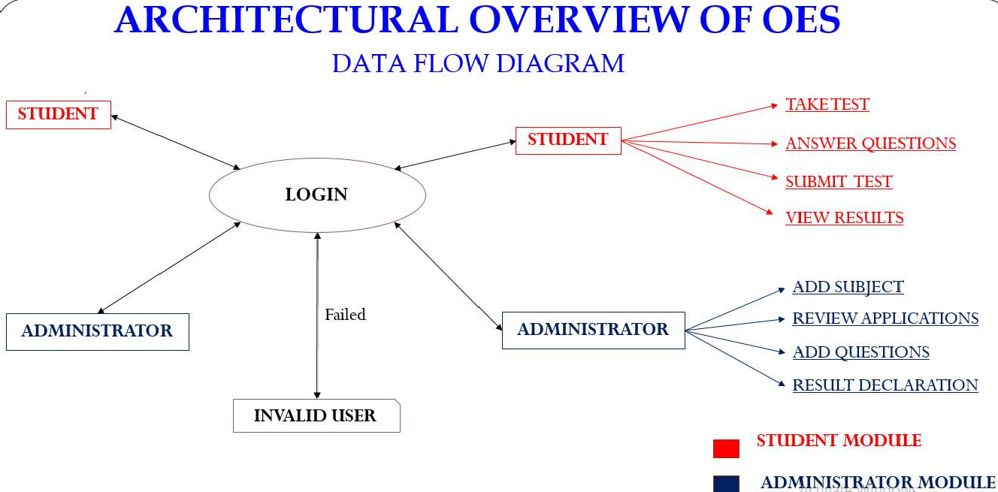

Fig 1

**USER**

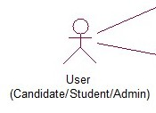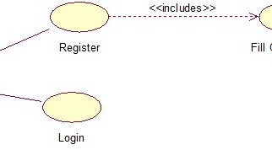

Fig 2

**ADMIN**

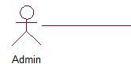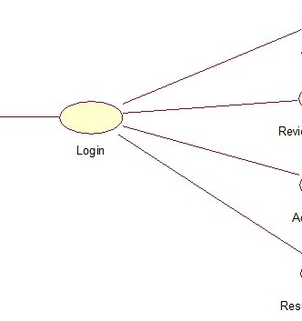

Fig 3

**USER / ADMIN**

Fig 4

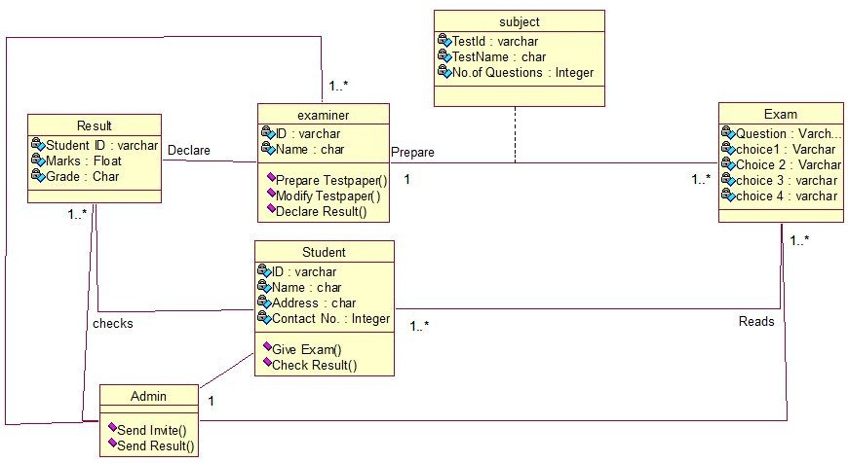**CLASS DIAGRAM FOR ONLINE EXAMINATION SYSTEM**

Fig 5

**SEQUENCE DIAGRAM FOR ONLINE EXAMINATION SYSTEM**

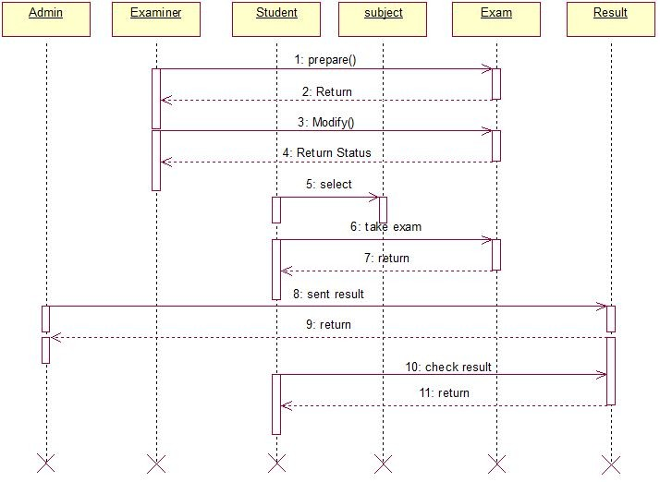

Fig 6

## **IMPLEMENTATION**

Implementation marks the pivotal stage of the project where the conceptual design transitions into a functioning system. This phase is crucial for ensuring the success of the new system and instilling confidence in users regarding its effectiveness. It involves meticulous planning, assessment of the existing system and its limitations on implementation, devising strategies for transition, and evaluating the effectiveness of these strategies.

**MODULE DESCRIPTION:**

a. ADMIN MODULE:

The admin initiates registration in the Online Examination System (OES), comprising five distinct sub-modules:

• Login: Enables admin access to the OES platform by providing valid credentials, granting access to the home page upon successful authentication.

• Manage Category, Subjects, and Exams: Facilitates the administration of categories and subjects (e.g., programming, sports) and management of exams related to these categories.

• Add Category, Subjects, and Exams: Allows the addition of new categories or subjects and enables activation or deactivation of exams.

• Check Users: Enables the admin to verify user information within the OES platform by entering valid usernames.

• Print Individual or Group Results: Provides functionality for printing individual or group exam results.

b. USER MODULE:

The user module enables alumni registration in the Academic Information System (AIS), with six sub-modules implemented:

• Registration: Facilitates user registration in the OES by providing necessary details such as full name, hall ticket number, and email address, granting access upon successful registration.

• Login: Allows users to log into the OES platform by entering valid email IDs and passwords authenticated by the admin.

• Change Password: Enables users to modify their passwords for enhanced security.

• Select Exam: Empowers users to choose the type of exam they wish to undertake.

• Take Exam: Provides users with the opportunity to participate in various exam types, including sports or programming exams.

• Submit Exam: Allows users to submit completed exams for assessment.

• View Result: Permits users to access their exam results, which can be displayed using pie diagrams and saved in PDF format.

**TABLES**

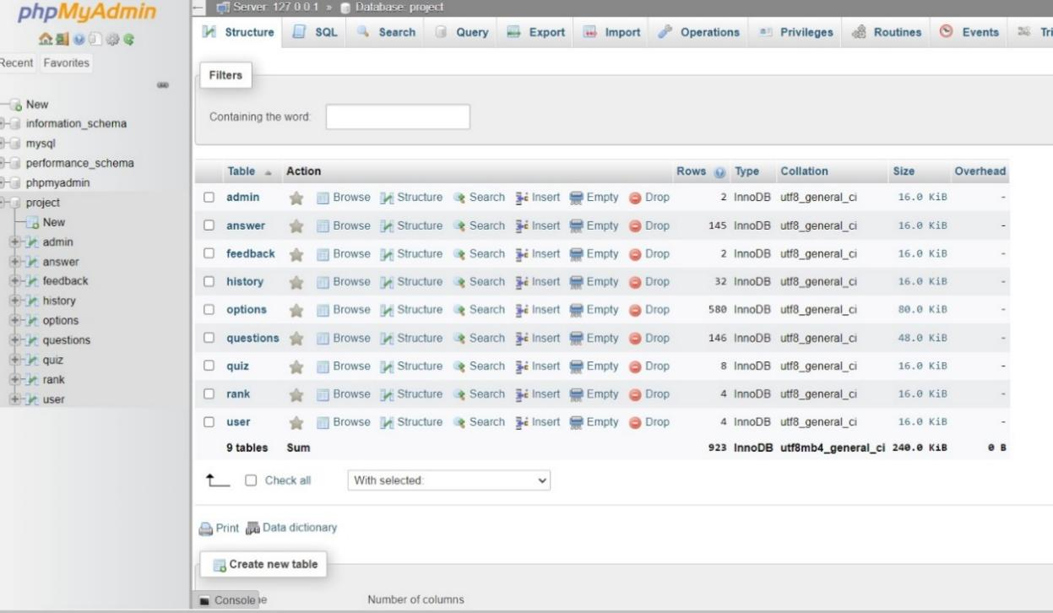

Fig 7

**ADMIN**

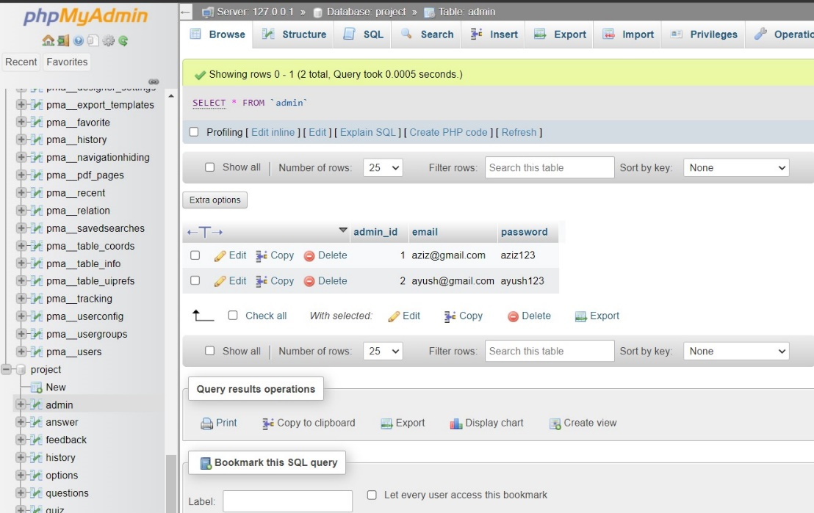

Fig 8

**ANSWER**

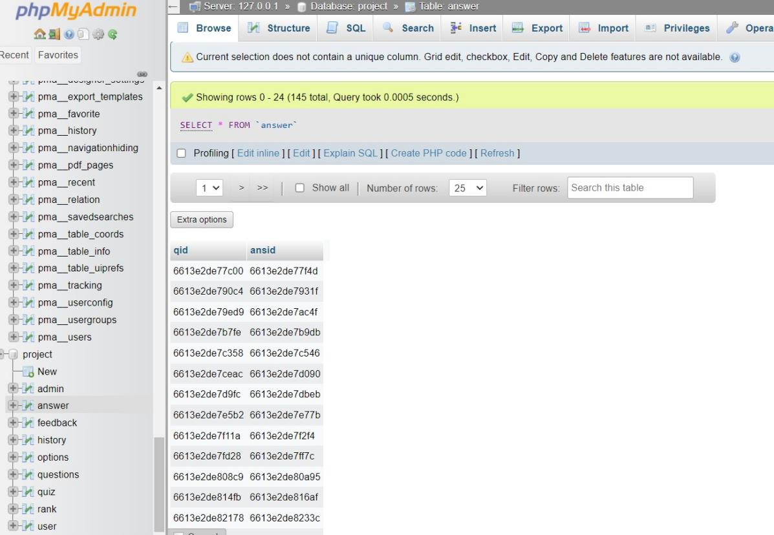

Fig 9

**FEEDBACK**

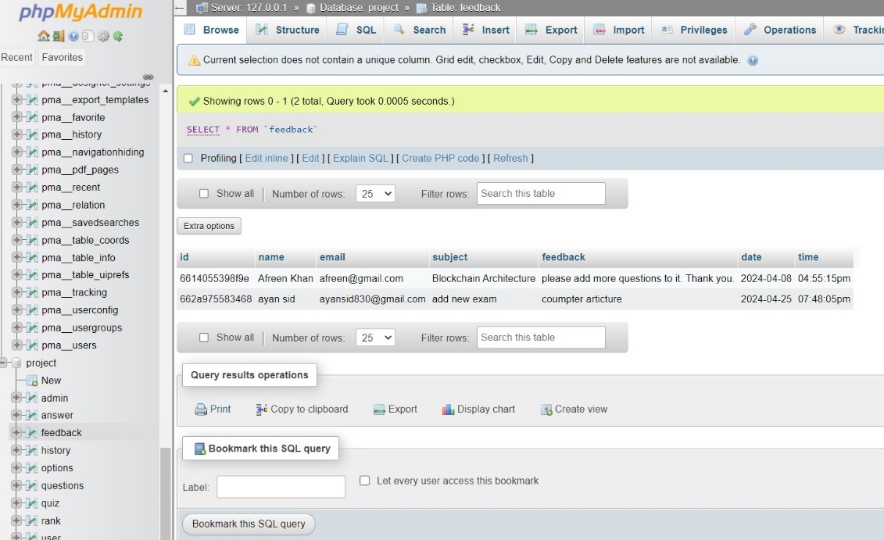

Fig 10

**HISTORY**  
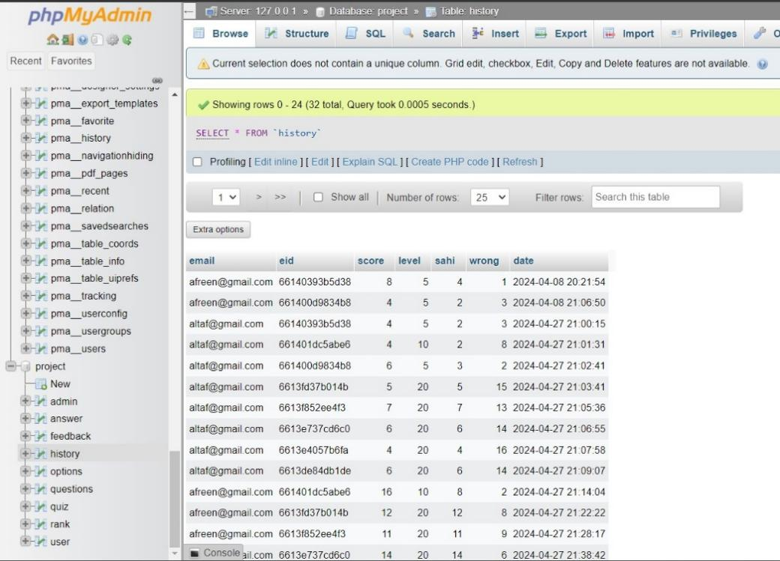

Fig 11

**OPTONS**  
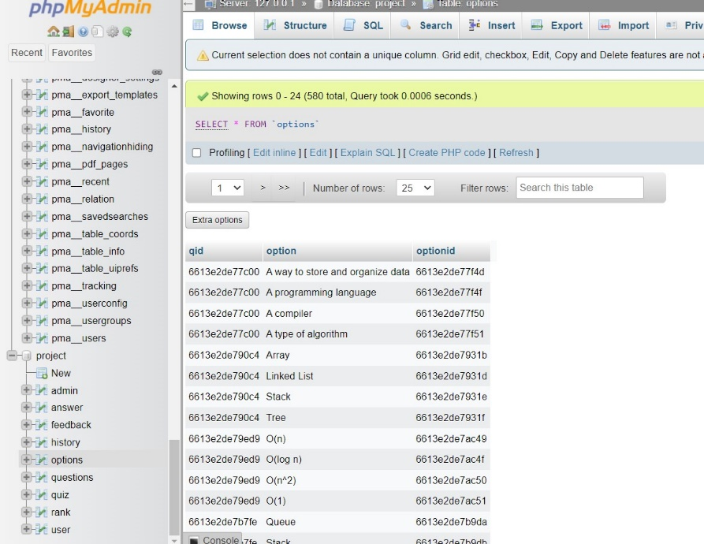

Fig 12

**QUESIONS**

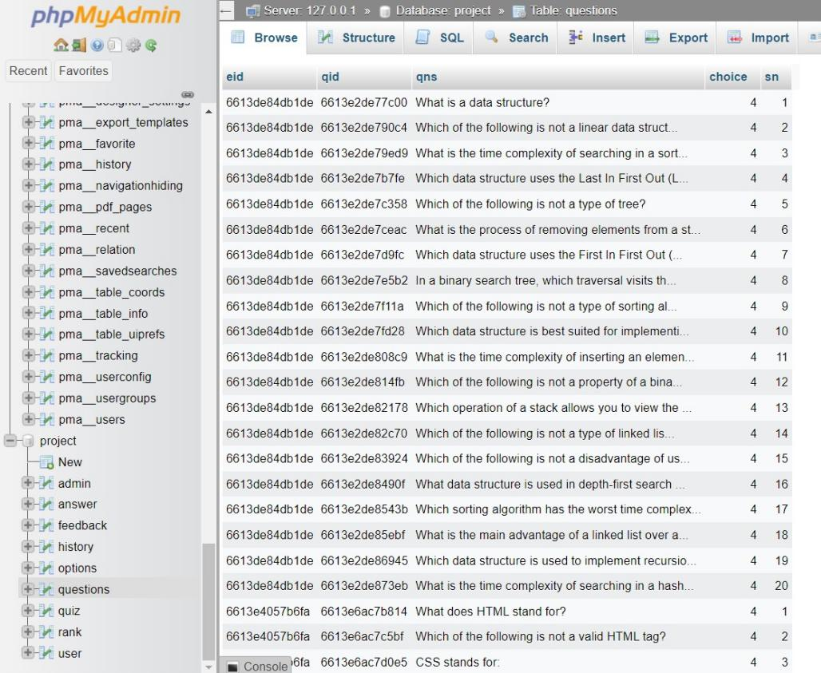

Fig 13

**RANK**

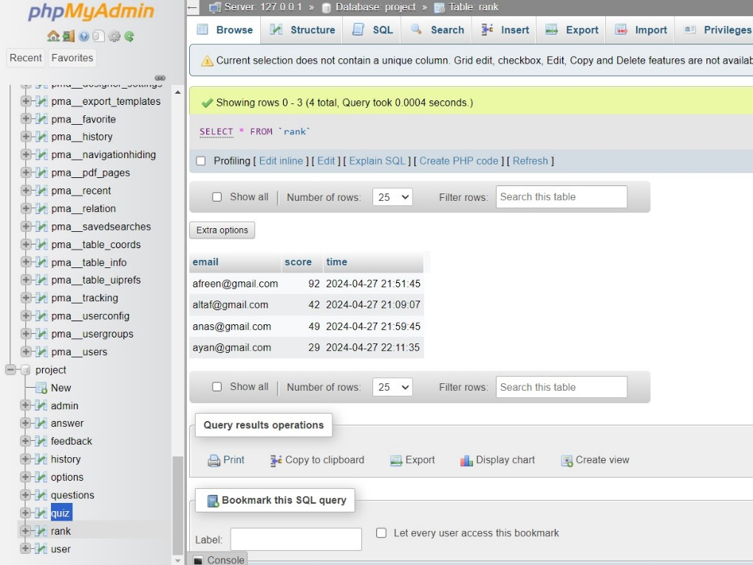

Fig 14

**QUIZ**  
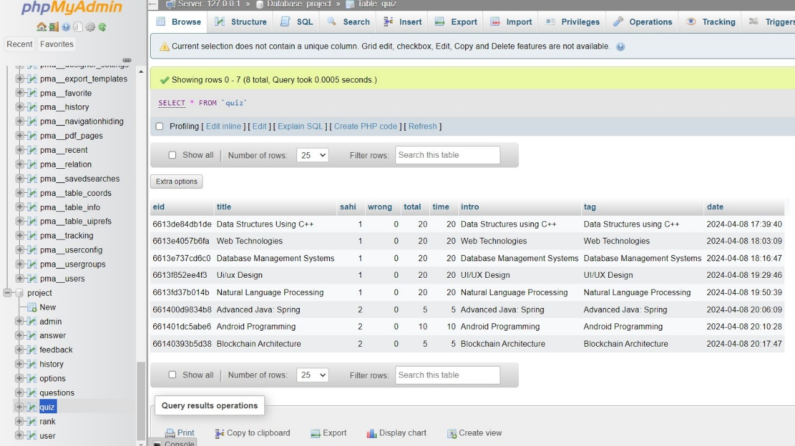

Fig 15

**USER**  
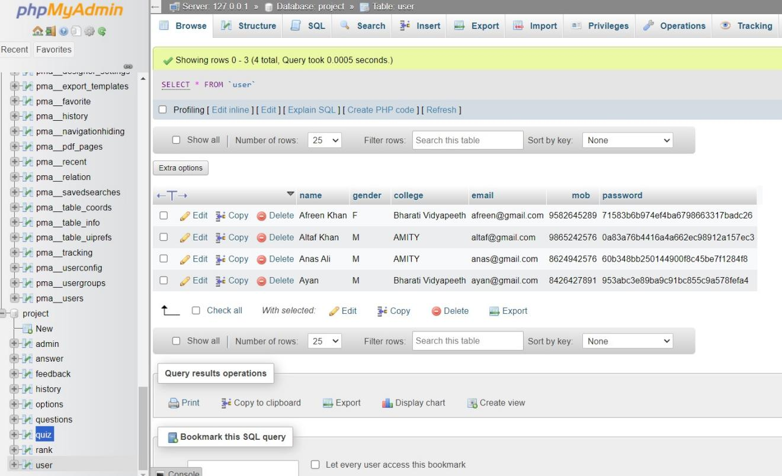

Fig 16

**TESTING**

Testing represents a critical phase in the software development lifecycle, serving as the linchpin for validating the functionality and performance of a program or system in alignment with its intended objectives. It serves as the bedrock of software quality assurance, transcending mere procedural steps to become an ongoing and iterative process that seamlessly integrates with the software development workflow. This holistic endeavor extends across various stages, spanning from initial analysis and design to subsequent implementation, execution, and ongoing maintenance.

The comprehensive nature of testing necessitates its inclusion throughout the entirety of the software development lifecycle, ensuring that each phase receives the necessary scrutiny to uphold the quality standards of the final product. From the conceptualization and planning stages through to coding, testing, and post-deployment maintenance, testing remains a constant and essential companion, continuously validating the integrity and functionality of the software at every turn.

Embracing a multidimensional approach, testing encompasses a spectrum of activities, each tailored to address specific facets of software functionality and performance. From the meticulous analysis of requirements to the meticulous design and implementation of test cases, testing traverses a diverse terrain, navigating through various testing methodologies, techniques, and tools to uncover potential issues and ensure optimal software performance.

In essence, testing transcends the boundaries of a singular phase or activity, permeating every aspect of the software development process to safeguard the integrity, reliability, and usability of the final product. It is a journey of perpetual refinement and validation, a continuous quest to ensure that software systems operate flawlessly in accordance with their intended purpose, thereby bolstering the confidence of stakeholders and end-users alike in the quality of the software being developed.

**Outlined below is the Testing Strategy:**

1. **Unit Testing:**

Unit testing is a fundamental component of the software testing process where individual units or components of a software application are tested independently to ensure that they function correctly in isolation.

**Key aspects of unit testing include:**

1. Isolation: Each unit, typically a single function, method, or class, is tested independently of other units. This isolation helps in identifying and fixing bugs at an early stage.

2. Automation: Unit tests are often automated, allowing for quick and frequent execution during the development process. Automated tests help maintain code quality and facilitate continuous integration and delivery practices.

3. Scope: Unit tests focus on testing the smallest units of code, ensuring that they behave as expected and meet their specifications. This involves testing different scenarios, including typical use cases, edge cases, and error conditions.

4. Mocking and Stubbing: In some cases, external dependencies such as databases, network services, or other modules are replaced with mock objects or stubs to isolate the unit being tested. This helps in controlling the environment and making tests more deterministic.

5. Fast Feedback: Unit tests provide rapid feedback to developers, allowing them to identify and address issues early in the development cycle. This iterative process of writing tests, running them, and fixing any failures helps in improving code quality and maintainability.

Overall, unit testing plays a crucial role in ensuring the reliability, maintainability, and scalability of software applications by validating the behavior of individual units of code in isolation.

1. **Integration Testing:**

Integration testing is a phase in the software testing process where individual software modules or components are combined and tested as a group to ensure they function together seamlessly as an integrated system.

**Key aspects of integration testing include:**

1. Combining Modules: In this phase, previously tested individual modules are integrated to form larger components or subsystems. These components are then tested together to verify their interactions and interfaces.

2. Top-Down or Bottom-Up Approach: Integration testing can be performed using either a top-down or bottom-up approach. In the top-down approach, testing starts with the highest-level modules and progresses downward, while in the bottom-up approach, testing starts with the lowest-level modules and progresses upward.

3. Test Cases: Test cases are developed to validate the interactions between modules and ensure that data is passed correctly between them. Test cases cover various scenarios, including normal use cases, boundary conditions, and error conditions.

4. Interface Testing: Special emphasis is placed on testing the interfaces between modules to ensure that data is exchanged correctly and that communication protocols are followed.

5. Stubbing and Drivers: In cases where all modules are not available for testing, stubs or drivers may be used to simulate the behavior of missing modules. Stubs simulate the behavior of lower-level modules, while drivers simulate the behavior of higher-level modules.

6. Integration Strategies: Different integration strategies, such as big bang, top-down, bottom-up, and sandwich testing, can be employed based on project requirements and constraints.

Integration testing helps identify defects related to module interactions, data exchange, and system integration early in the development lifecycle, reducing the risk of issues during system testing and deployment. It ensures that the integrated system meets its functional and non-functional requirements and performs as expected in a production environment.

1. **Validation Testing:**

Validating testing, often referred to as validation testing, is a critical phase in the software testing process aimed at confirming that a software product or system meets the specified requirements and satisfies the needs of its stakeholders.

**Key aspects of validation testing include:**

1. Requirement Verification: Validation testing begins by ensuring that the software product aligns with the documented requirements and meets the expectations of stakeholders. This involves reviewing requirements documents, user stories, and acceptance criteria to verify that they have been correctly implemented.

2. Functional Testing: Functional testing verifies that the software functions as intended and performs the tasks specified in the requirements. Test cases are designed to cover various functional aspects of the software, including user interfaces, business logic, data manipulation, and workflow processes.

3. Non-functional Testing: In addition to functional testing, validation testing also includes non-functional testing to assess the software's performance, reliability, usability, security, and other quality attributes. Non-functional tests evaluate factors such as response times, scalability, availability, and compliance with regulatory standards.

4. User Acceptance Testing (UAT): User acceptance testing is a crucial part of validation testing where end-users or representatives from the target audience validate the software against their real-world needs and use cases. UAT ensures that the software meets user expectations and is fit for deployment.

5. Regression Testing: Regression testing is performed to ensure that changes or enhancements to the software do not introduce new defects or negatively impact existing functionality. Regression test suites are executed to validate that previously tested features still work as expected after modifications.

6. Alpha and Beta Testing: Alpha and beta testing involve releasing the software to a limited group of users or testers (alpha) and then to a broader audience (beta) to gather feedback and identify any remaining issues before final release. These testing phases provide valuable insights into real-world usage scenarios and user satisfaction.

7. Compliance and Standards Testing: Validation testing also includes verifying compliance with industry standards, regulations, and best practices. This may involve conducting audits, inspections, or assessments to ensure that the software meets applicable legal and regulatory requirements.

Overall, validation testing ensures that the software meets quality standards, fulfills user needs, and delivers value to stakeholders. It provides confidence in the software's readiness for deployment and use in production environments.

**4.Acceptance Testing:**

Acceptance Testing is a crucial phase that encompasses the planning and execution of various tests, including functional, performance, and stress tests. The primary objective is to demonstrate that the implemented system meets its specified requirements. Key tools utilized during acceptance testing include:

- Testing Coverage Analyzer: This tool records the control paths followed for each test case, providing insights into the extent of code coverage achieved during testing.

- Timing Analyzer (Profiler): Also known as a profiler, this tool reports the time spent in different regions of the code, highlighting areas that require attention to improve system performance.

- Coding Standards Compliance Tools: Static analyzers and standard checkers are employed to inspect code for deviations from established coding standards and guidelines. These tools ensure consistency and adherence to best practices throughout the development process.

During acceptance testing, these tools play a pivotal role in ensuring the robustness, performance, and compliance of the implemented system with specified requirements. Their strategic application helps in validating the system's functionality, performance under various conditions, and adherence to coding standards.

Testing is synonymous with quality assurance. It involves executing a program with the goal of uncovering errors. A successful test case is one that is highly likely to detect previously unidentified errors. There are two primary methods for testing any engineering product. One approach, known as "BLACK BOX TESTING," focuses on demonstrating that each designed function operates effectively by conducting tests based on the product's intended functionality without delving into its internal workings.

Understanding the inner workings of the product allows for testing to ensure that all internal components operate in accordance with specifications and are thoroughly exercised. This method, known as "WHITE BOX TESTING," focuses on verifying that the internal operations of the product align with expectations. Both white box and black box testing approaches offer mechanisms to enhance test completeness and increase the probability of uncovering software errors. The objectives of verification and validation are to assess and enhance the quality of work products produced during software development and modification.

Two types of verifications exist:

(1) life-cycle verification and (2) formal verification.

Validation takes place at the end of the software development process and involves assessing the software. Quality assurance, conversely, is a systematic and planned series of actions aimed at ensuring adequate confidence that the item complies with technical requirements. Walkthroughs involve collaborative sessions where the material under review is presented and evaluated by a team of reviewers. Inspection entails examining the software life cycle to enhance the quality of work products. Life-cycle verification evaluates how well the work products of a development phase meet the specifications set in earlier phases. Formal verification is a rigorous mathematical proof of how source code aligns with its specifications. Although high quality can be achieved through testing source code alone, it's uncommon for large software products to be completely error-free. The three main categories of software errors are requirement errors, design errors, and implementation errors.

**Test Case Document (TCD):**

Within the Test Case Document, we encapsulate essential aspects aimed at ensuring the thorough testing of the "Academic Status Entry" form, a pivotal component residing within the student module of our university management system application.

**1. Test Scope:**

The Test Scope meticulously delineates the breadth and depth of our testing endeavors, specifically targeting the "Academic Status Entry" form. This entails a comprehensive coverage strategy, focusing on various facets and functionalities integral to the form's operation.

**2. Test Scenario:**

Embedded within the Test Scenario is a narrative that vividly illustrates the real-world usage of the "Academic Status Entry" form by office personnel. This scenario unfolds as these personnel engage with the form to input academic marks, compute status details, persist student-related information, and gracefully conclude their interaction with the form.

**3. Test Procedure:**

The Test Procedure serves as our roadmap for effectively executing the testing regimen designed for the "Academic Status Entry" form. It meticulously outlines a structured approach, meticulously planned to scrutinize the form's functionalities across multiple dimensions. This encompasses rigorous evaluations of data entry mechanisms, meticulous calculations of status details, seamless execution of data-saving operations, and graceful navigation through form exit procedures. Our testing methodology is multifaceted, encompassing GUI testing, Positive testing, and Negative testing, each meticulously orchestrated to ensure comprehensive coverage and robust validation of the form's behavior and performance.

By adhering to this meticulously crafted Test Case Document, we aim to instill confidence in the reliability and performance of the "Academic Status Entry" form, thereby contributing to the overall quality and efficacy of our university management system application.

**OUTPUT SCREENS**

**Login /Sign-in Page:** This is the login page where users can sign in, new users can create accounts, admins can access administrative functions, developers' names are listed, and users can provide feedback.

Fig 17

**User Sign-In:** This feature allows individuals who already have accounts on your website to access their personalized content, settings, or services. Users typically input their username/email and password combination to authenticate their identity and gain entry.  
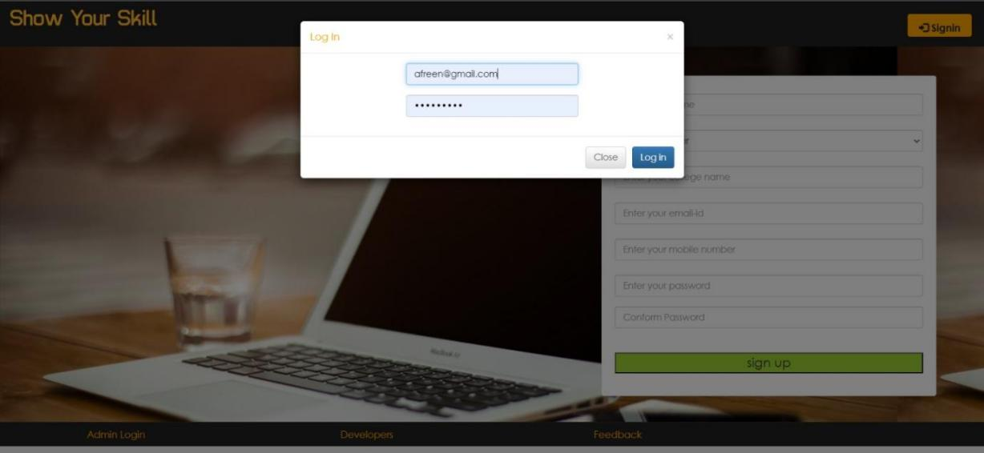

Fig 18

**User Sign-Up:** For new visitors or those who don't have an account yet, the sign-up option provides a means to create a new account. This process often involves providing basic information such as a username, email address, and password, and sometimes additional details depending on your website's requirements.  
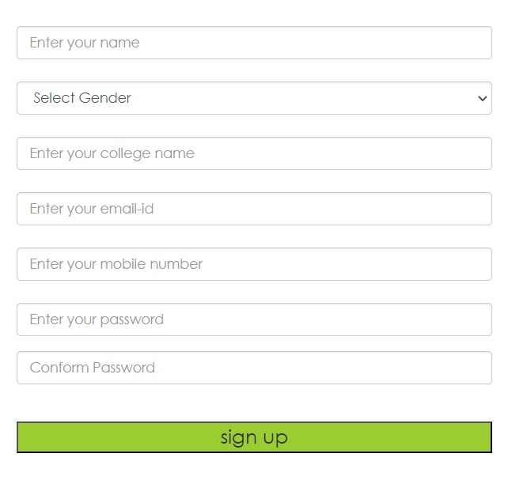

Fig 19

**Admin Login:** This functionality is specifically designed for administrators or privileged users who have elevated access rights to manage and oversee the website. Admins use their unique credentials to access administrative panels or dashboards where they can perform tasks such as content management, user management, and site configuration.



Fig 20

**Developer Recognition:** Acknowledging the contributions of developers adds a personal touch to your website and fosters transparency. Listing the names of the developers can instill trust among users and showcase the collaborative effort behind the creation and maintenance of the website.  


Fig 21

**Feedback Section:** User feedback is invaluable for improving your website's usability, functionality, and overall user experience. Providing a dedicated feedback section encourages users to share their thoughts, suggestions, or concerns, which you can use to make informed decisions for future enhancements and optimizations.  
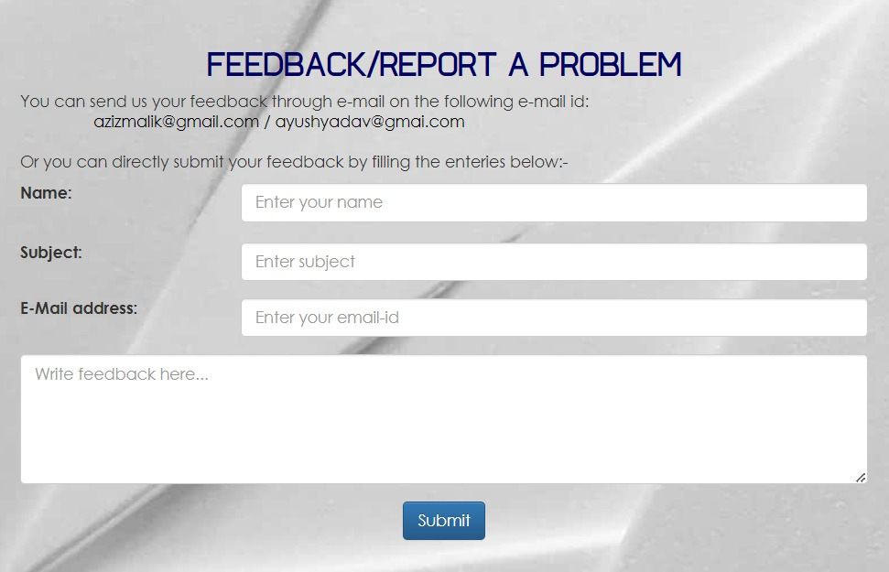

Fig 22

By incorporating these elements into your website's login page, you're offering a comprehensive experience that caters to both user needs and administrative requirements while fostering a sense of community and collaboration through developer recognition and user feedback.

**ADMIN HOME PAGE**

This is the admin home page, featuring sections for home, user information, rankings displaying students' exam scores, user feedback, quiz management for adding or removing quizzes, and sign-out functionality.  
**Home:** The home section serves as the starting point for administrators, offering a dashboard or landing page that provides a snapshot of key information or activities relevant to the administration of the website or application. This could include recent notifications, system status updates, or quick access links to commonly used tools or reports.

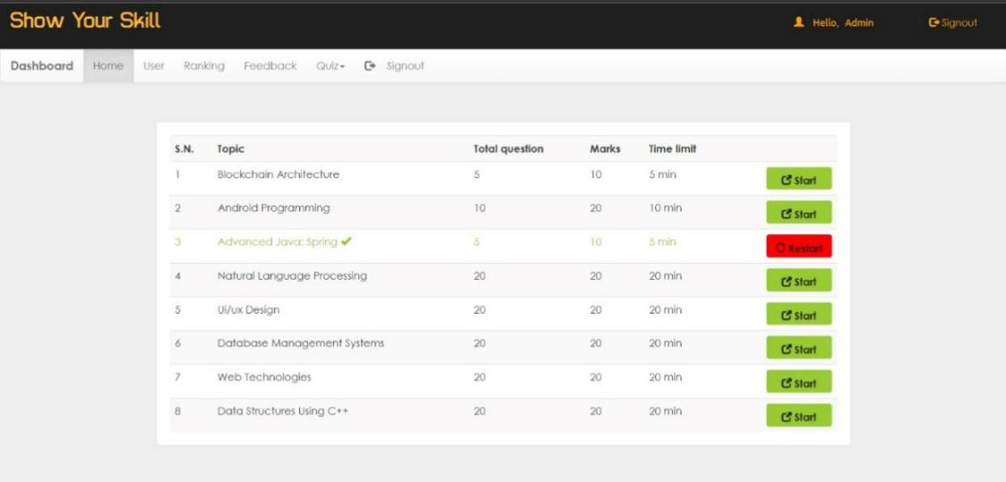

Fig 23

**User Information:** This section allows administrators to access and manage user-related data. It might include features such as user profiles, where admins can view and edit user details, activity logs to track user actions within the system, or account management tools for tasks like account creation, suspension, or deletion.

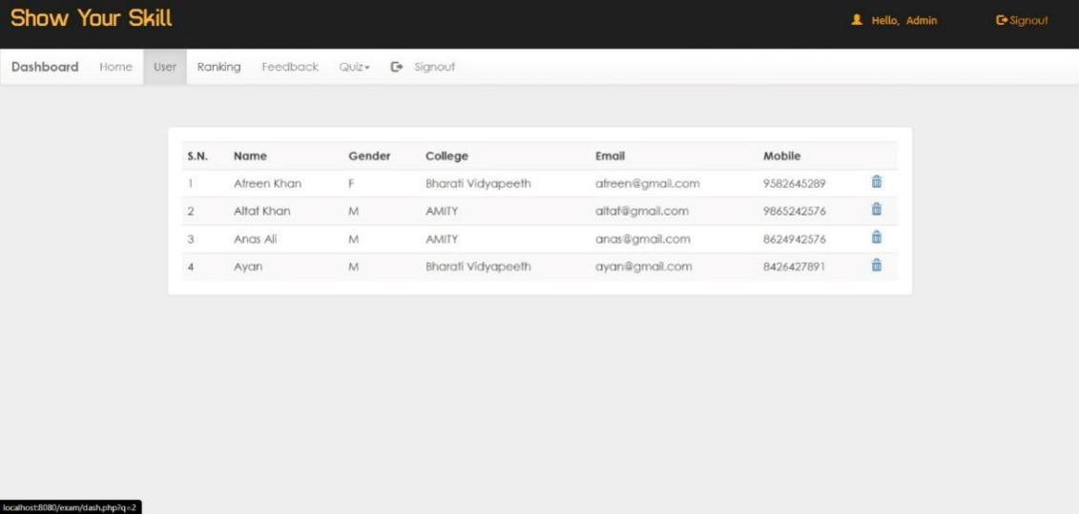

Fig 24

**Rankings:** The rankings section displays the performance rankings of students based on their exam scores or other relevant metrics. Admins can use this information to identify top-performing students, track progress over time, or identify areas where additional support may be needed.

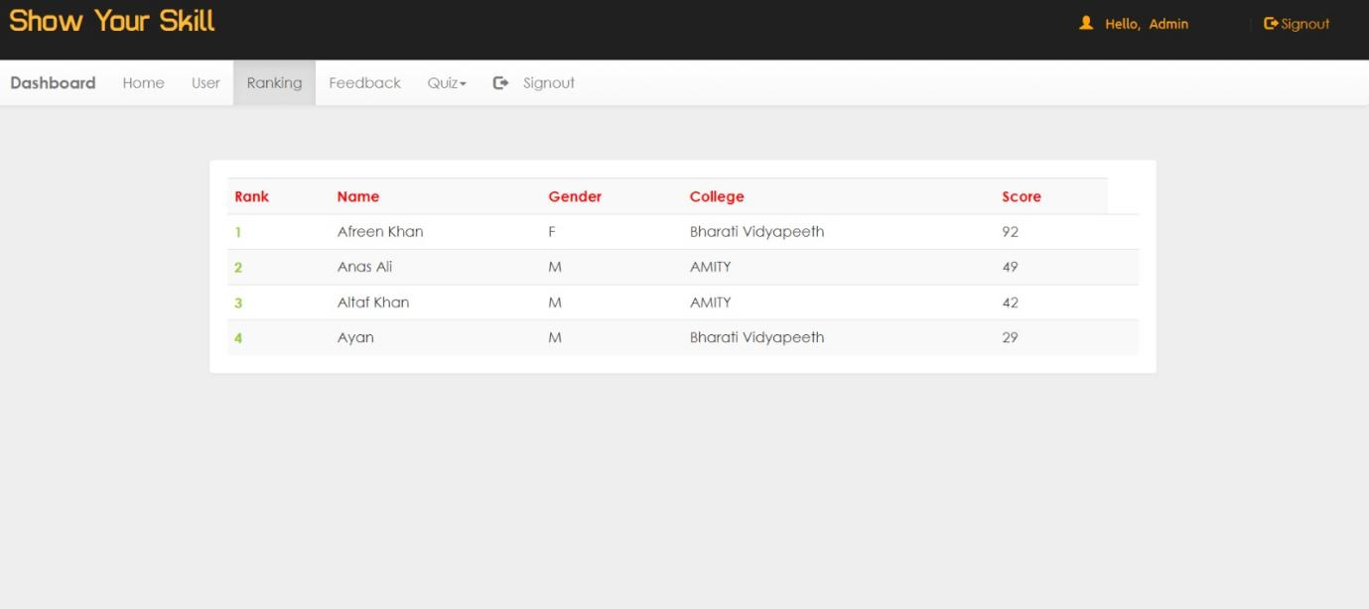

Fig 25

**Feedback:** In this section, users can provide feedback, suggestions, or comments to administrators. Admins can review and respond to feedback to address user concerns, implement requested features, or gather insights for future improvements to the platform.

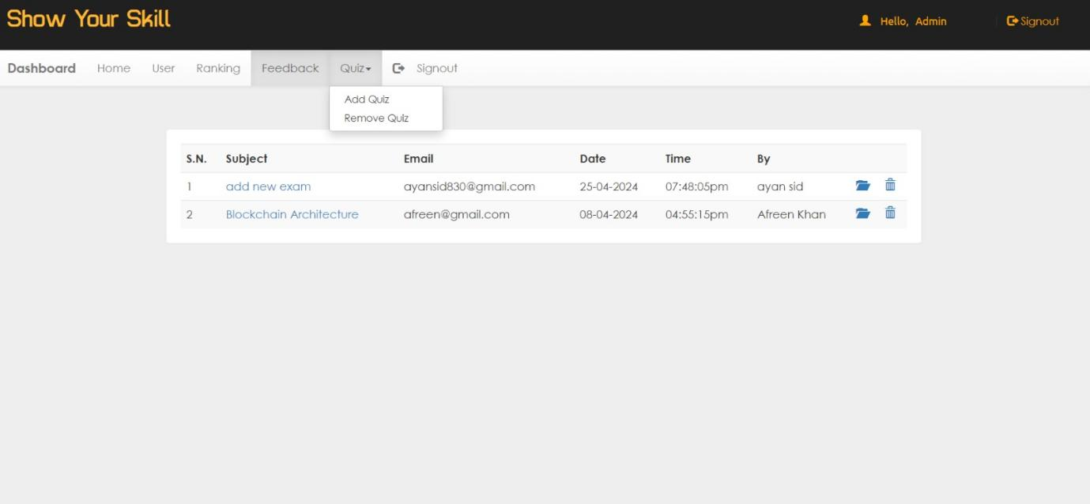

Fig 26

**Quiz Management:** Quiz management tools enable admins to create, edit, and manage quizzes within the system. This includes functionalities such as adding new quiz questions, editing existing quizzes, setting up quiz schedules, and removing outdated quizzes. Admins can also review quiz results and analytics to assess student performance and identify areas for improvement.



In Fig 27 we can add or remove quiz  
  
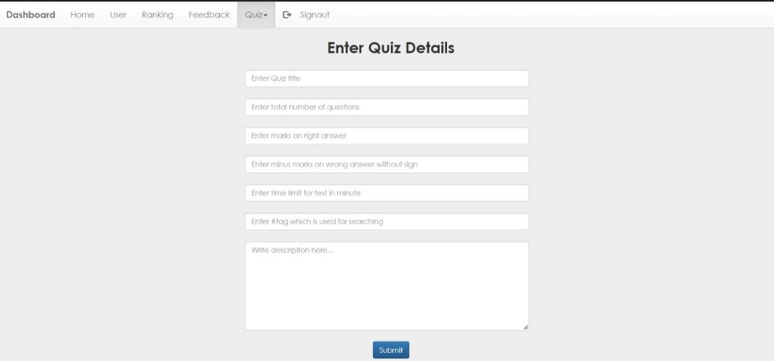

In Fig 28 admin can enter quiz details and submit it for users to use the quiz

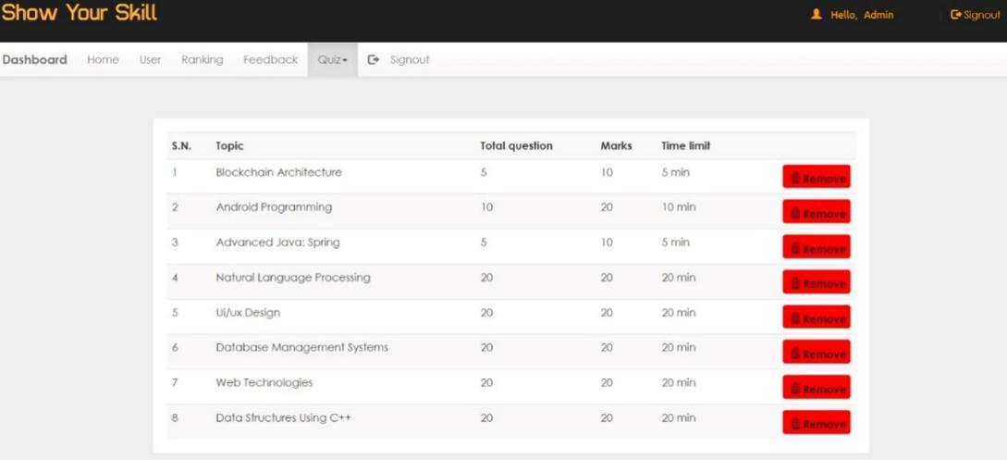

In Fig 29 admin can remove the Quiz

**Sign-out:** The sign-out feature allows administrators to securely log out of the admin interface when their session is complete. This helps ensure account security by preventing unauthorized access to sensitive administrative functions or data.

Fig 30

By incorporating these elements into your admin home page, you provide administrators with a comprehensive set of tools and features to effectively manage users, track performance, gather feedback, and administer quizzes, ultimately enhancing the overall functionality and usability of the platform.

**STUDENT/USER HOME PAGE**  
This is the user or student home page, featuring a dashboard for quick access to essential functions, a history section displaying past exam records, a ranking section showing user standings, and a sign-out option for logging out securely.

**Dashboard/Home:** This section provides users or students with a central hub where they can access various features and information relevant to their use of the platform. It typically includes widgets or panels displaying personalized data such as upcoming exams, recent activity, notifications, or any announcements from the platform administrators.   
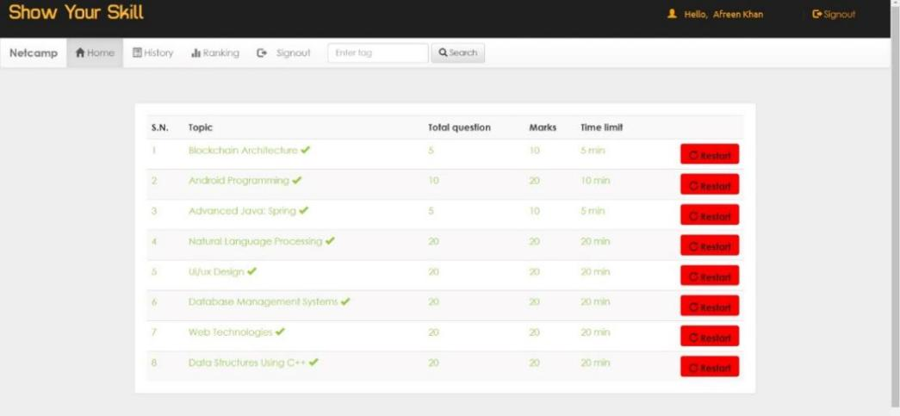

Fig 31

**Exam History:** The exam history section enables users to review their past performance by accessing a comprehensive record of all the exams they have taken on the platform. Each entry in the exam history may include details such as the exam name, date, duration, scores, and any feedback provided by the system or instructors

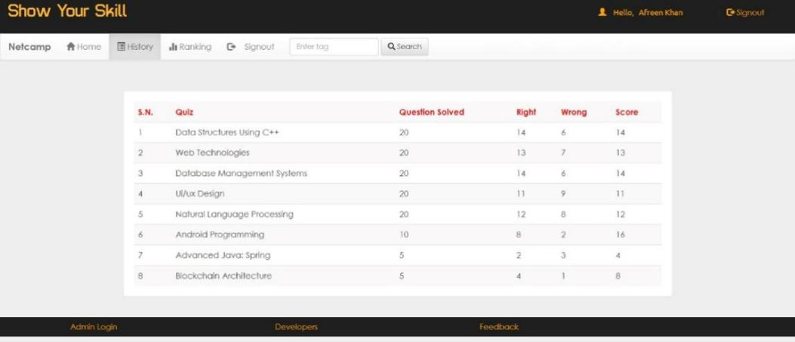

Fig 32

**Ranking:** In the ranking section, users can view their relative standing compared to other students or users of the platform. Rankings may be based on various criteria, such as overall exam scores, subject-specific performance, or participation in certain activities. This feature allows users to benchmark their performance against their peers, fostering healthy competition and motivation for academic improvement. Additionally, rankings can serve as a source of recognition for high-achieving users and encourage engagement with the platform.

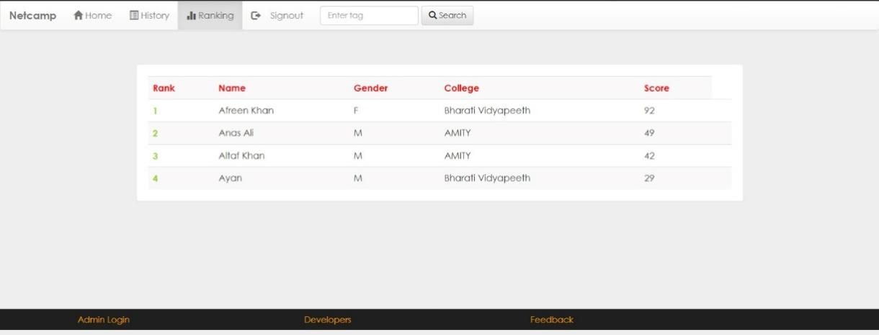

Fig 33

By incorporating these elements into your user or student home page, you create a comprehensive and user-centric experience that empowers users to track their progress, access important information, and engage with the platform effectively

# CONCLUSION AND FUTURE SCOPE

**Conclusion**

The Online Examination System was meticulously designed to alleviate the cumbersome task of manually assessing candidates' answers. This innovative system not only reduces the workload for teachers and administrators but also alleviates student anxiety by providing instant and automated feedback on responses. By transitioning from traditional paper-based assessments to a digital platform, the system streamlines processes and significantly reduces paperwork. Comprising modules for both administrators/examiners and students, the Online Examination System is a user-friendly web application that facilitates efficient examination management and result generation. Through thorough analysis of its positive attributes and limitations, it is evident that the system is a highly effective GUI-based component, fully aligned with user requirements and capable of seamless integration into various educational institutions.

**Future Scope**

The Online Examination System holds immense potential for future enhancements and expansions. While the current system offers valuable features, there are numerous opportunities for further development and refinement. Some potential upgrades for future implementation include:

1. Automated issuance of online certificates directly to registered email addresses.

2. Implementation of mobile alerts to notify new users upon successful registration.

These upgrades not only enhance the functionality and user experience of the system but also extend its applicability to a broader range of educational institutions, making it a versatile solution for modern examination management needs.

## **BIBLIOGRAPHY**

“Beginner to Intermediate Php5” by Mario Lurig.

“PHP: The Complete Reference” by Steven Holzner.

<http://www.javatpoint.com/php/>

[www.google.com.](http://www.google.com.)

[www.w3schools.com.](http://www.w3schools.com.)

